Adaptive Sampling Working Group Meeting Report
Tuesday, November 12, 2002
Princeton University
Introduction:

Much progress has been made in integrated adaptive sampling strategies for AOSN-II since the initiation of this project. Many different research groups have already established good working relationships. It was agreed that in addition to performing adaptive sampling to improve the model predictive skill metrics and the science metrics, there will be some experimental investigations in MB’03 that demonstrate methodologies for contribution to adaptive sampling in future experiments. These experiments will be judged according to metrics developed by the adaptive sampling working group. For example, since efficiency in glider use for adaptive sampling is of central importance, approaches that have been developed for exploiting flow predictions to optimize glider network motion will be tested and judged according to their ability to minimize time and energy used by gliders to travel to a given destination. All methodologies will be well-tested and well-tuned in simulation in advance of MB’03. For example, in coordinated network strategies, approaches should be well-tuned to cope with challenges associated with infrequent glider/shore communication and lack of inter-vehicle communication.

There was a great deal of interest in discussing infrastructure at this meeting and this is reflected in work done on the Adaptive Sampling block diagram shown below. Jim suggested as an action item that we develop “Use Cases” which tell the story of how things are going to work.

Notes Taken During Discussion of Overview Adaptive Sampling Block Diagram:

Categories for adaptive sampling fleet:

- Two sets of gliders
  - Routine (approximately 5 to 6 gliders)
  - Tasked, more adaptive (approximately 5 to 6 gliders)
- Two sets of glider goals
  - Transit (priority is to get somewhere)
  - Survey (priority is to collect data at current location/region)
- Two sets of sensors carried
  - With bioluminescence (BL) sensor
  - Without BL sensor
- Two real-time models
  - HOPS (ESSE)
  - ROMS (ETKF)
- Two kinds of data to feed back
  - Model data
  - Observational data
- Many options for glider allocation and configuration. E.g., for the tasked group, consider 1 group of 6 in a uniform distribution,2 groups of 3 or 6 groups of 1, etc.

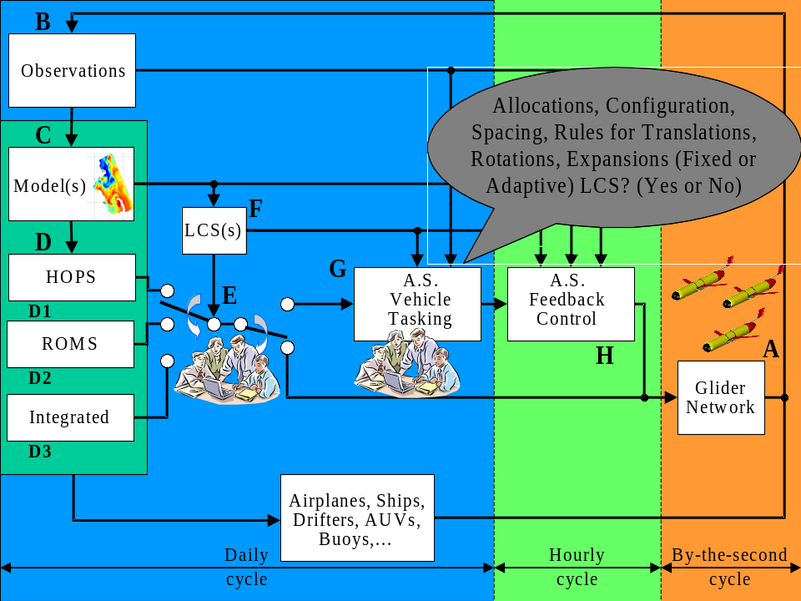

Definition of Connections in Overview Adaptive Sampling Block Diagram. Letters refer to those in the block diagram above.

A to B:
- Raw data from the gliders go by satellite to WHOI data server.
- Raw data gets QC’d at 1MB/day at WHOI (vertical profiles).

B to C: QC vertical profiles → boxed average in model grid.

C to D: Models

D to E:
- To be determined Nov. 13 how to choose HOPS vs ROMS vs Integrated HOPS/ROMS both in terms of the specific hotspot identification (i.e., prescribing regions of interest for glider fleet to explore) and in terms of which model data set should be used in Boxes F, G and H.

E: (some general guidelines)
- Use blocks G and H most heavily for tasked gliders as opposed to routine gliders.
- Bypass blocks G and H as back-up.

(D → E) → G
- Center of region of interest and radius, with priorities for tasked gliders?
- More complex shapes to represent features?
- Coarse waypoints?
- Track lines for routine gliders?
- How much human involvement?

C to F: Input to LCS (Lagrangian Coherent Structures) computations
- Current vector fields 1/hr for 2 times model cycle or more? (20 X 20 or 40 X 40 field)

F to G: DLE (Direct Lyapunov Exponent) field (20 X 20 or 40 X 40 field), interpolated?

B to G: Glider locations for determination of vehicle tasking for adaptive sampling.

B to H:
- Glider locations
- Glider profiles

C to H: Currents – 1hr resolution grids? Needs analysis.

G to H: Control parameters for adaptive sampling feedback control strategies.

