Ecosystem Effects of Closed Areas in the Western Gulf of Maine

Lead Agency:
David Bergeron, Executive Director
Massachusetts Fishermen's Partnership
2 Blackburn Center
Gloucester, MA 01930
978-282-4847
dbergeron@mass-fish.org

Principal Investigator:  Prof. Allan R. Robinson  Harvard University  29 Oxford Street  Cambridge, MA 02138  617-495-2819  robinson@pacific.deas.harvard.edu | Co- Principal Investigator:  Dr. Pierre Lermusiaux  Harvard University  29 Oxford Street  Cambridge, MA 02138  617-495-0378  pierrel@pacific.deas.harvard.edu | Co- Principal Investigator:  Prof. James McCarthy  Harvard University, MCZ  26 Oxford St.  Cambridge, MA 02138  617-495-2330  jmccarthy@oeb.harvard.edu

Budget Request: $279,574

Abstract:
The main goal of this cooperative proposal is to study, characterize and predict physical transport processes with direct implications for understanding potential pathways of replenishment from closed areas to regions open to fishing in the Western Gulf of Maine (WGoM) with a focus on the transport of larvae of Atlantic Cod and American Lobster. The approach is based on a novel, reliable, observing, monitoring, modeling and predicting system for the WGoM, with application to particle tracking and material dispersion. It will draw on the considerable empirical knowledge and data of local fishermen and on previous experience at Harvard University and National Marine Fisheries Service (NMFS) in the region and generally. Expected results of this demonstration of concept include: i) a better understanding of dynamical processes that affect circulation and transport in the WGoM, including aspects of storm response and tidal processes, with an emphasis on Massachusetts Bay; and, ii) an enhancement of ongoing relevant biological studies based on the simultaneous evaluation of physical data and plankton information relevant to assessing the closures as potential source areas. Importantly we expect to demonstrate the utility and potential of involving the knowledge base and seagoing resources of the commercial fishermen and their fleet in oceanographic/ecosystem-science/fisheries management studies.
2. RATIONALE
This project initiates an investigation of the ecosystem effects of closed areas in the Western Gulf of Maine (WGoM) as possible source regions of larvae to replenish areas open to harvesting, with a focus on Atlantic Cod and American Lobster. To do so, an observing system for collecting relevant ocean data using local fishing fleets will be developed and tested. These data will be studied and assimilated into physical-biological ocean models of the Harvard Ocean Prediction System (HOPS, e.g. Robinson, 1999) and used to predict the dispersal of spawning products released in the closed areas, focusing on the WGoM closure area, with an emphasis on Massachusetts Bay. This project is also a demonstration of concept for a fishing vessel based observing system to gather data and enhance regional ocean monitoring/modeling/predicting capabilities, which aims to be sustained over time. This should provide new options for evaluating management tools under Ecosystem-Based Fishery Management.

Our study is part of a broad research initiative, the “Fishermen's Initiative for Scientific Habitat & Ecosystem Research” (FISHER) that is being coordinated by the Massachusetts Fishermen’s Partnership (MFP) to establish a foundation for an ecological understanding of the dynamical WGoM ecosystem structure and function. The initiative focuses on understanding ecosystem processes that will help to ensure sustainable harvesting of key species. The long-term scientific focus is on the understanding of the complex dynamics of the marine ecosystem in the WGoM. It has multiple vital socioeconomic impacts, including fisheries and coastal management.

Assimilation of physical and biogeochemical ocean data (Robinson and Lermusiaux, 2002) into the HOPS interdisciplinary forecasting system will provide the environmental background fields for the protected areas and the adjacent regions. By coupling these fields with plankton data collected in this project, an analysis can be undertaken to examine transport of eggs and larvae of Atlantic cod and larvae of American lobster.

The present proposal originated from a collaborative prioritization of research questions. Although information is rapidly accruing on the role of closed areas in the Gulf of Maine in terms of their increases in biomass (Murawski et al., 2000), far less is known in terms of their role as egg and/or larval source areas (Fogarty and Murawski, in press). Both fishermen and scientists recognize storm and tidal processes as important forcing mechanisms on regional oceanic properties and ecosystem dynamics (e.g. lobsters), especially during stratified spring-to-fall ocean conditions and strong tidal forcing (e.g. spring tides about every 14 days). Scientists and fishermen believe that and oceanographic/ecosystem approach to these questions merits immediate attention.

This project strongly supports each of the Northeast Consortium’s major goals to 1) develop partnerships among commercial fishermen, scientists and managers, 2) enable commercial fishermen to participate in cooperative research, 3) help bring fishermen’s knowledge and expertise in to the scientific arena, and 4) equip and utilize commercial fishing vessels as research platforms.

3. REVIEW OF PREVIOUS WORK
HOPS (http://oceans.deas.harvard.edu/HOPS) has been developed at Harvard University for physical and physical-biological ocean dynamical studies and forecasting in several ocean regions. It consists of data analysis and assimilation schemes (Robinson, 1999; Lermusiaux et al., 2002), and coupled interdisciplinary (physical, acoustical, optical, biogeochemical) dynamical models. It is a generic system that can be used for fundamental process studies and applied to any region of the world ocean. Operational physical forecasts have been carried out for nearly two decades at Harvard and at other national and international centers. Coupled physical-acoustical (Robinson and Lermusiaux, 2003) and physical-biogeochemical (Besiktepe et al., 2003) real-time data assimilation and dynamical studies have also been carried out. The ability to accurately forecast Lagrangian particle paths with HOPS (Lermusiaux, 2001) has been demonstrated in real applications, including for example hindcasts for the drift of Staccato (e.g.,
http://people.deas.harvard.edu/~robinson/Staccato/staccato.html) and the forecasts of floating debris for the Egypt Air Flight 990 accident in the New England Continental Shelf-break region (http://people.deas.harvard.edu/~robinson/EA990/EA990.html). A new version of HOPS with a free surface is now available and operational (http://oceans.deas.harvard.edu/haley/FreeSurf). Tidal forcing is implemented via barotropic tidal forcing at the boundaries obtained by inversion of tidal gauge data and large-scale barotropic tidal constituents.

The LOOPS (Littoral Ocean Observing and Prediction System, LOOPS: Massachusetts Bay Sea Trial-98) project focused on the development of the scientific and technical conceptual basis of an interdisciplinary national littoral laboratory system. The overall goal was to develop the concept of a generic, versatile and portable system, applicable to multidisciplinary, multiscale coastal processes. Intended LOOPS applications included scientific research, coastal zone management and rapid environmental assessment for naval and civilian emergency operations.
The LOOPS advanced systems concept consisted of: A modular, scalable structure for linking, with feedbacks, models, observational networks and data assimilation algorithms; and an efficient and robust, integrated and distributed, system software architecture and infrastructure. The main LOOPS sea trial occurred in Massachusetts Bay in September-October 1998 (MBST-98). Dynamical results are described in (Robinson and the LOOPS group, Lermusiaux, 2001 and
Besiktepe et al., 2003).

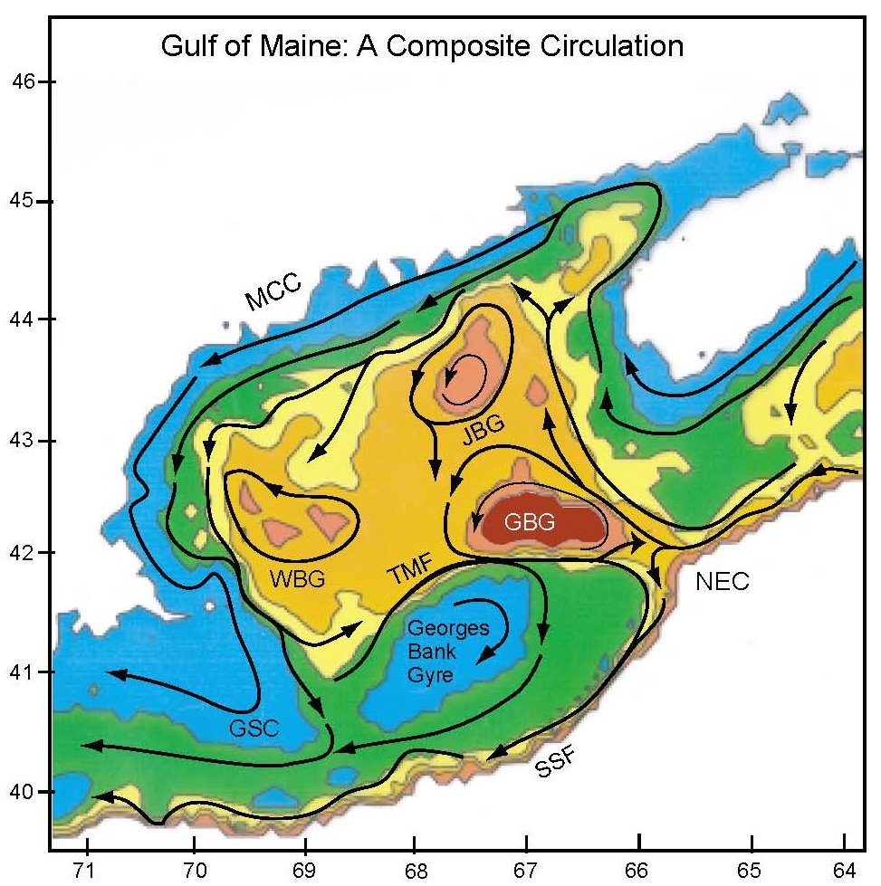
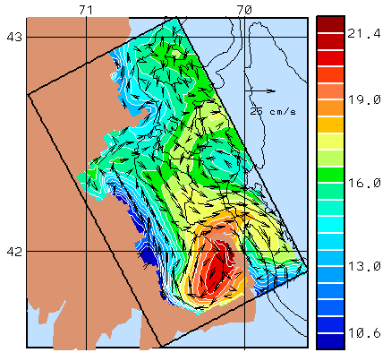
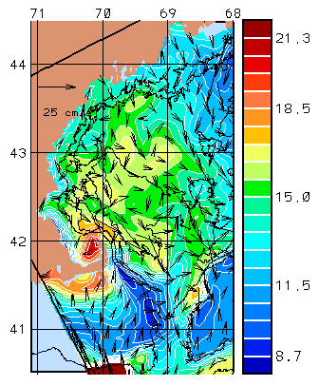
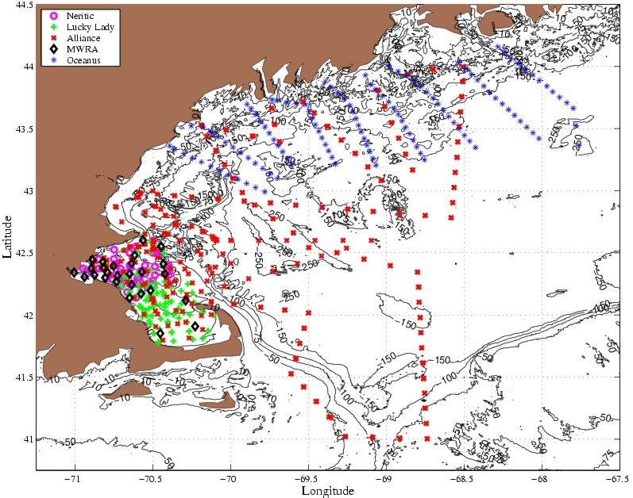
ASCOT-01 (http://people.deas.harvard.edu/~leslie/ASCOT01/index.html, Assessment of Skill for Ocean Transients), which focused on the GOM/Massachusetts Bay region built upon the earlier success of LOOPS. The general circulation in the GOM is illustrated in Fig. 1a. During June 2001, the NRV Alliance (NATO) conducted a physical oceanographic survey for the full region of study (Fig. 1c) while two smaller vessels, the R/V Neritic (UMass-Boston) and R/V Luck Lady (UMass-Dartmouth) made station observations in Massachusetts Bay for physical, chemical, and biological properties and processes. Via HOPS the data assimilation, error analysis, and prediction systems developed in LOOPS and related projects were applied to this particular field experiment to maximize the opportunity to capture the biological response of a wind-driven mixing event in Massachusetts Bay (Fig. 1b). The corresponding real-time HOPS circulation in the northern GOM is illustrated in Fig. 1d. Due to the limited resources available for station sampling by the two smaller vessels, this field aspect of ASCOT-01 was considered a pilot project to demonstrate the potential to use models of atmospheric forcing and physical oceanographic processes to predict event conditions conducive for enhancements in biological productivity. The core of this work forms the Harvard Ph.D. dissertation of Patricia Moreno (jointly supervised by Robinson and McCarthy).
Fig. 1 – a) schematic of Gulf of Maine circulation; b) surface temperature and sub-tidal velocity in Mass. Bay during ASCOT-01; c) ASCOT-01 composite sampling; and, d) surface temperature and sub-tidal velocity in the Western GOM during ASCOT-01. Note that the scales in b) and d) are different.
c)
b)
d)
a)
a)
b)
The National Marine Fisheries Service (NMFS) and collaborators have evaluated the effect of the imposition of year-round fishery closure areas in the Gulf of Maine and on Georges Bank for evidence of a reserve effect (build-up of biomass within the closed areas) and spill-over effects influencing catch rates in the vicinity of the closed areas (Murawski et al. 2004; Fogarty and Murawski 2005; Murawski et al. 2005). These analyses have clearly demonstrated increases in biomass for several commercially important groundfish species (notably haddock, yellowtail flounder, and cod) and for commercially valuable invertebrate species such as sea scallops within the closed areas. Increases have been most dramatic for haddock and for scallops (Fogarty and Murawski, 2005).

Evaluation of catch rates and fishing effort distribution near the closed areas shows a marked concentration at the boundaries of the closed areas with approximately 25% of the effort occurring within 5 km of the closed area borders (Murawski et al. 2005). Evidence for spill-over effects, represented by a clear gradient in catch rates as a function of distance from the closed area boundaries was obtained for some but not all groundfish species with particularly clear evidence for haddock (Murawski et al. 2004). The average revenue per hour towed was twice as high within 5 km of the boundaries but was also more variable than in more distant locations.

Collectively, these results indicate the ecological and economic significance of the year-round closures. To date, less information on larval export from marine protected areas has accrued. Lagrangian particle tracking experiments to evaluate the potential export of sea scallop larvae from closed areas on Georges Bank have indicated that these marine protected areas can be self sustaining and also contribute to larval settlement in areas open to scallop dredging (reviewed in Fogarty et al. 2000; Fogarty and Murawski 2005). The proposed research would augment the information base on the role of larval subsidies to open areas to encompass two additional valuable resource species cod and lobsters.

4. PROJECT GOAL AND OBJECTIVES

The main goal of this cooperative proposal is to study, characterize and predict physical transport processes with direct implications for understanding potential pathways of replenishment from closed areas to regions open to fishing in the WGoM. Specific objectives include:
- Demonstrate a novel, reliable, observing, monitoring, modeling and predicting system for the WGoM, with application to particle tracking and material dispersion.
- Better understand dynamical processes that affect circulation and transport in the WGoM, including aspects of storm response and tidal processes, with an emphasis on Massachusetts Bay.
- Enhance ongoing relevant biological studies by evaluating together physical data and plankton information relevant to assessing the closures as potential source areas.
- Draw on the considerable empirical knowledge and data of local fishermen.
- Foster strong trusting relationships between commercial fishermen and scientists.

5. PROJECT PLAN AND EXPERIMENTAL DESIGN

5.1 Ecosystem Dynamics and Closed Areas
A complex mosaic of closed areas involving year round and seasonal fishery closures is now in place in the Gulf of Maine (Fig. 2). The WGoM is an area of importance for cod and an investigation of the potential role of the closed areas in this region with respect to cod abundance (Fig. 3) and egg and larval dispersal is of direct and immediate interest to management of this valuable resource. No published information on concentrations of adult lobster or of lobster larvae in the vicinity of the WGoM closed areas is currently available. However, earlier work in the nearshore WGoM (Lawton et al., 1982) indicated relatively high concentrations of lobster larvae off Manomet Point. It is therefore reasonable to assume that lobster larvae could be located in the vicinity of the closed areas. Particle tracking models have been used to infer the origin of lobster larvae located off Georges and Browns Banks with probable source locations linked to Penobscot Bay, ME and off Cape Cod, MA (Harding et al., in press).
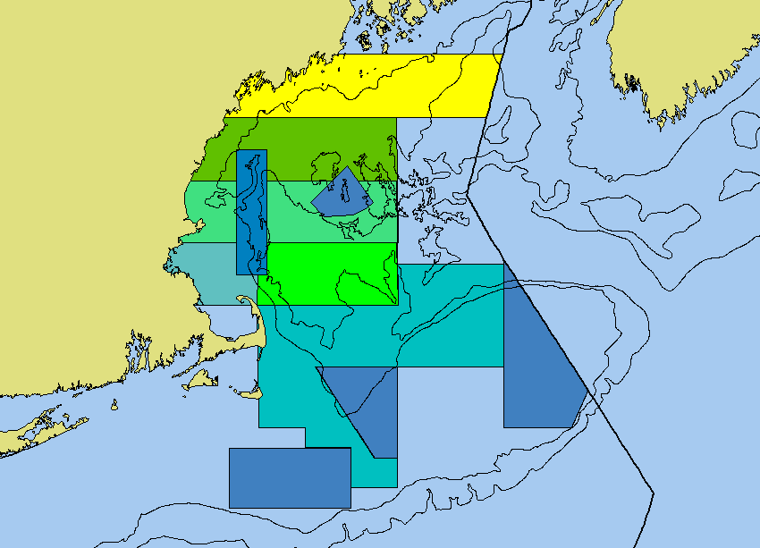
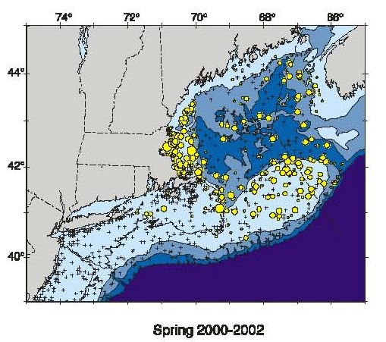

May
June
May
March
April

Nov.
-II
-I
LS
WGOM
CL
Georges Bank
Canada
USA
. New
England
Fig. 2 – Location of year-round closure areas in the Gulf of Maine (dark blue polygons) and seasonal Closure areas.
Fig. 3 – Cod abundance in the Gulf of Maine based on northeast Fisheries science center standardized bottom-trawl surveys.

The main physical features and important physical-biological sub-regions and processes in part of the WGoM Bay have been identified based on previous Harvard efforts (Fig. 4). These results stem from two recent important HOPS experiments (LOOPS98 and ASCOT-01). Massachusetts Bay is a 100 by 50 km semi-enclosed embayment adjacent to the Gulf of Maine. The mean circulation is observed to be cyclonic around the Bay (Geyer et al., 1992; Signell et al., 1993). This mean flow from Cape Ann to Race Point is mostly driven by remote forcings from the Gulf of Maine coastal current and mean wind stress (Bogden et al., 1996; Brown, 1998). During seasons with ocean stratification, when our planned experiments will take place, the mesoscale variability is significant. Importantly, the wind forcing often changes direction, with autocorrelation times of the order of a day. Strong wind events were found to alter the structures of the buoyancy flow and circulation features were found to be more variable than previously described, involving possibly one, two or three branches of the Gulf of Maine coastal current and several gyres, vortices, jets and rim currents (Robinson and the LOOPS Group, 1999; Lermusiaux, 2001).

The variability of the mesoscale circulation in Massachusetts Bay (Fig. 4) occurs on seasonal and weather driven scales. These, together with fluctuations in Gulf of Maine inflows, river discharges, (sub)-mesoscale internal dynamics, and external and internal tidal forcing drive a variety of coupled processes. Similarly, turbulent patches, small-scales, internal tides and waves just west of Stellwagen Bank have been observed to have a strong impact on biological variables. Because of all these processes, Massachusetts Bay is a pristine natural habitat and rich fishing grounds. Importantly, these processes still need to be studied and quantified.

In this initial phase of this project, the central purpose of our study of ecosystem dynamics and the effect of closed areas is the advective transport of larvae of Atlantic Cod and American Lobster. The primary focus is on the dispersion of larvae in the WGoM area. Additionally, storm and tidal advection effects on this dispersion will be studied in Mass. Bay.

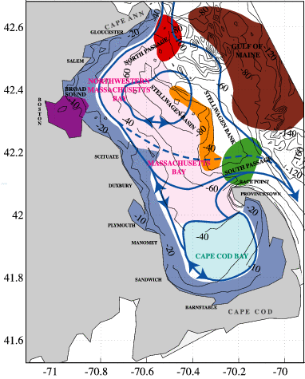
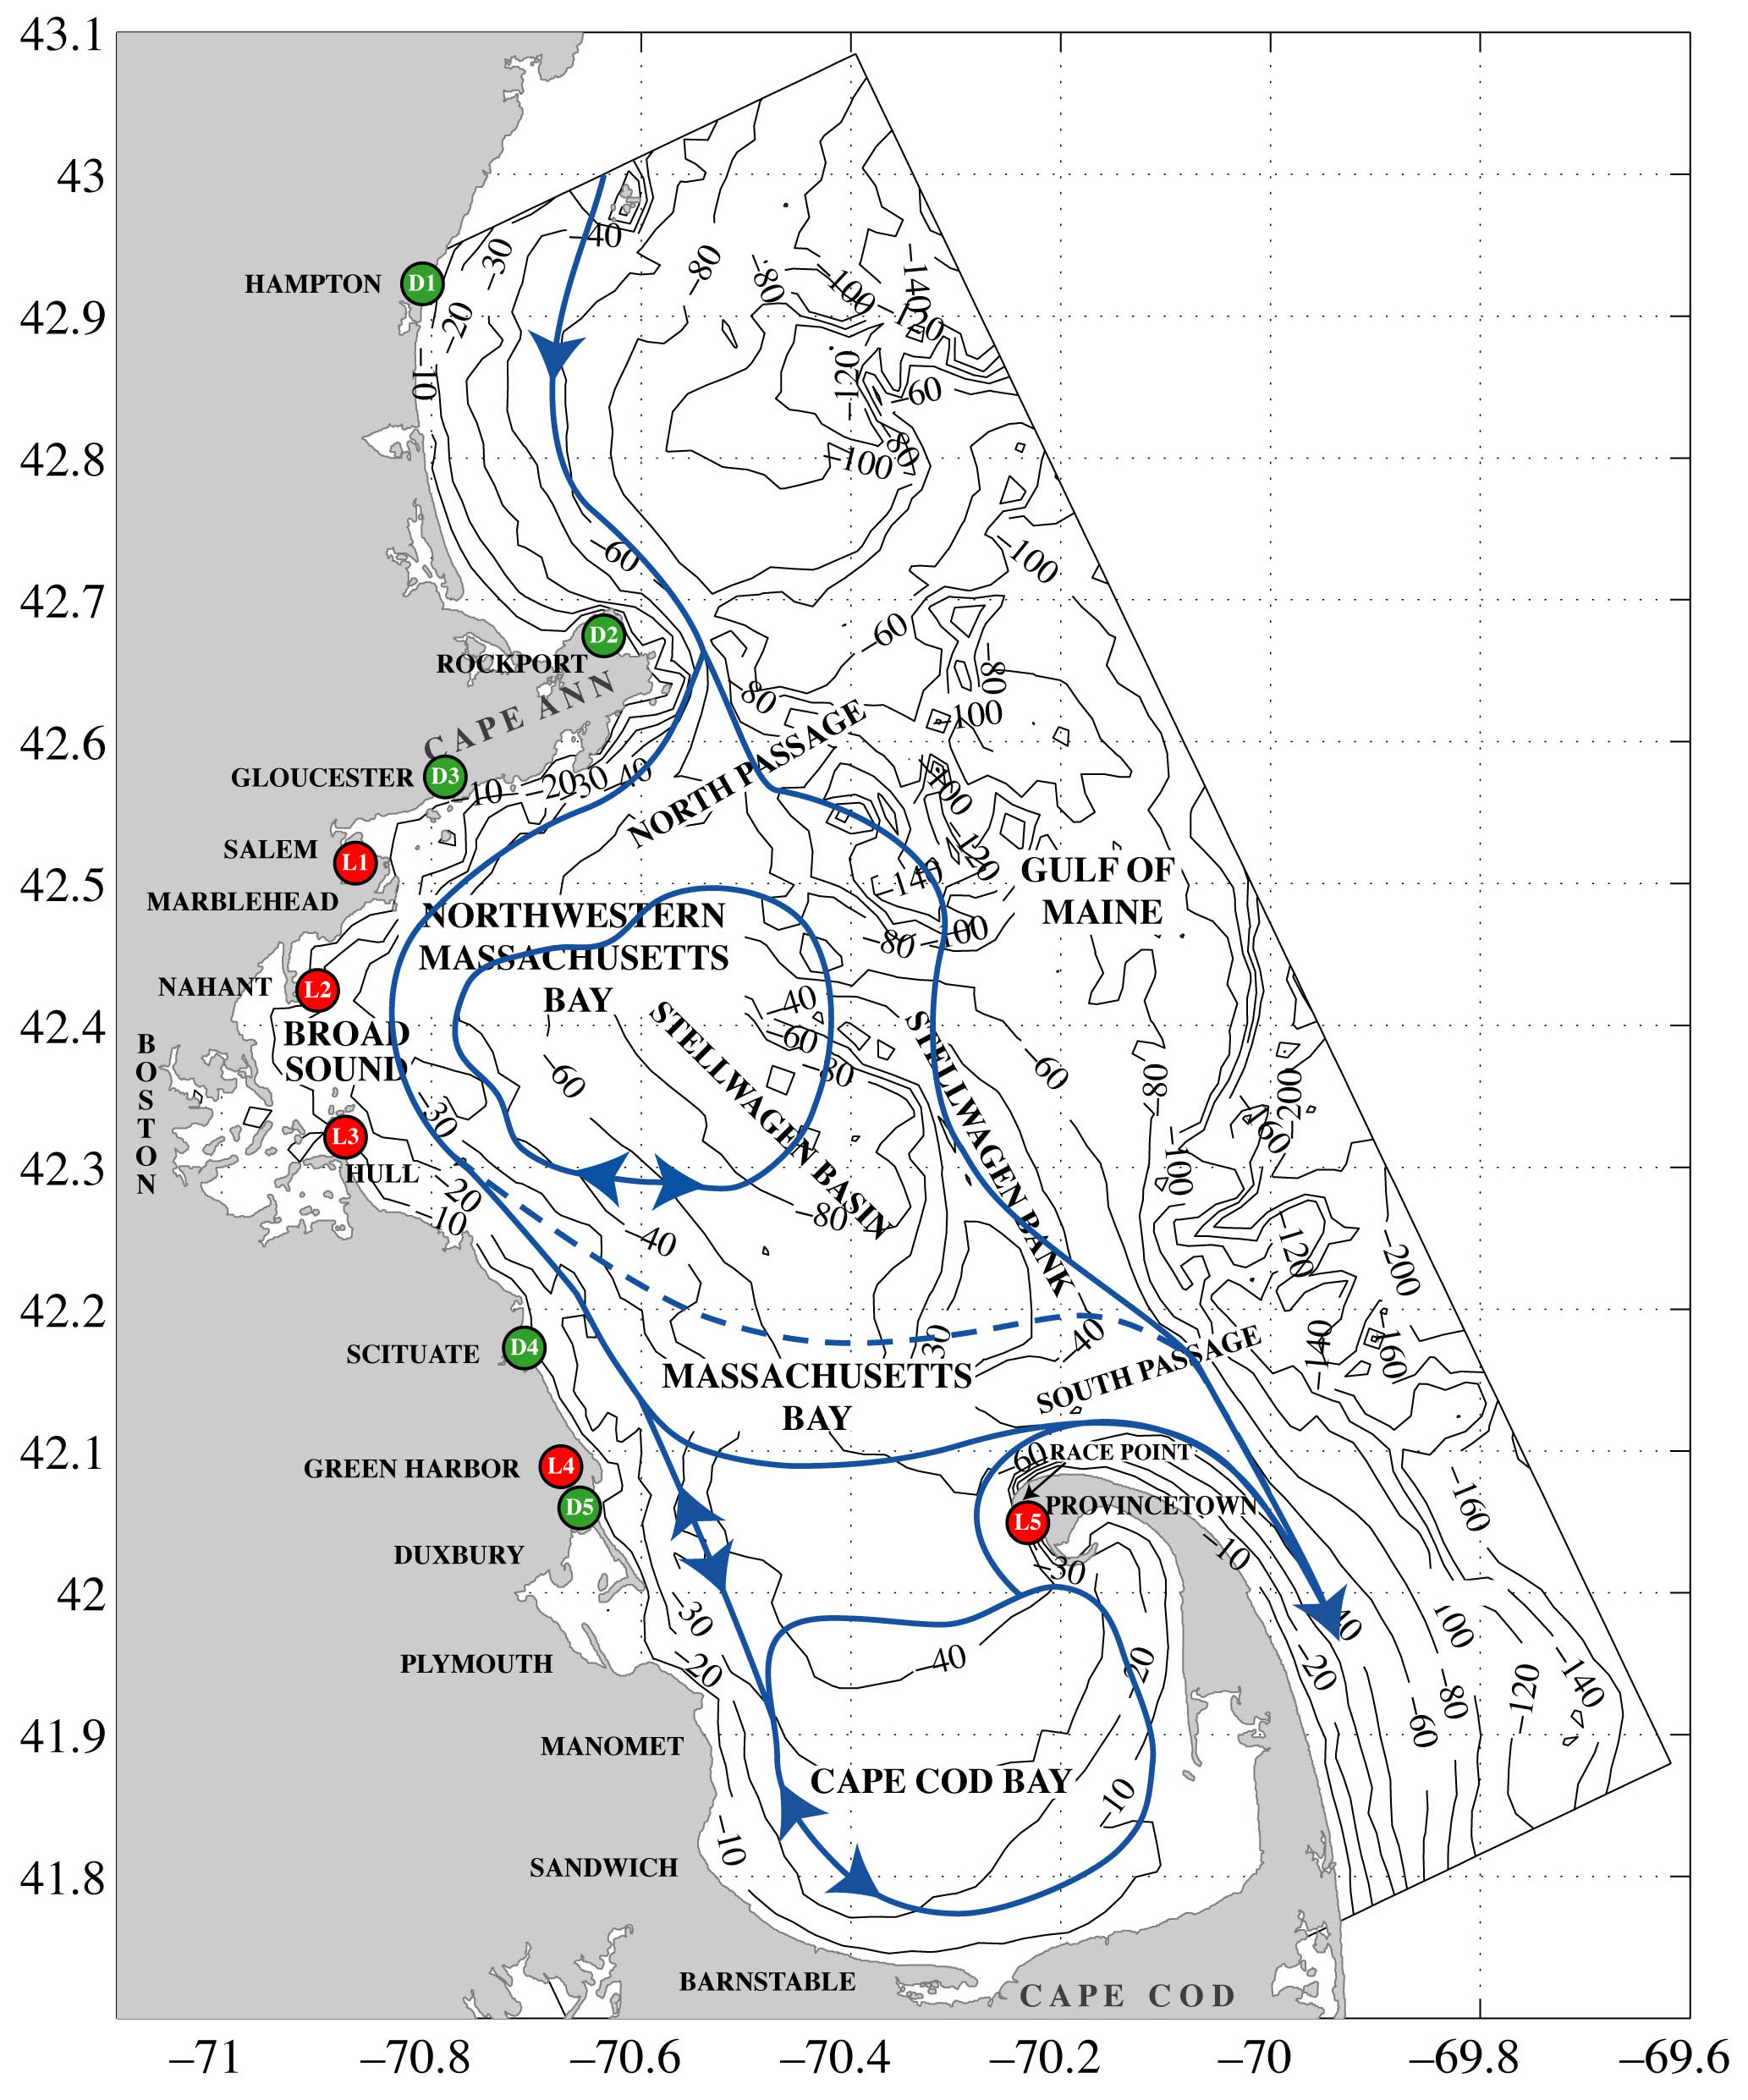
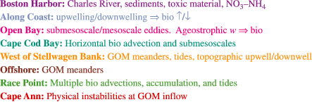
5.2 Oceanographic/Ecosystem Observing and Prediction System
Mass. Bay buoyancy circulation overlaid on: Fig. 4 - Physical-biogeochemical regions,
Fig. 5 - Port locations of fishing vessels (red - lobsters, green - trawlers) illustrate the geographic distribution of ports (for details on actual port locations see Table 1).
In order to establish a dependable data collection system using local commercial fishing vessels, a 1.5-year project will be undertaken. Ten fishing vessels (Table 1) will be outfitted with sensors for physical and biogeochemical variables. The data collected by the fishermen will be studied and assimilated into HOPS. The HOPS dynamical models will predict the ocean temperature, salinity and current fields, as well as ocean biogeochemical fields (nitrate, ammonium, chlorophyll, plankton, detritus, etc.) and predict dispersal pathways of spawning products of cod and lobster released in the closed areas. A subset of the fishing vessels will be equipped with plankton nets to sample eggs and larvae.
Our project aims to start on January 1, 2006 and terminate on June 30, 2007. The intensive sampling and prediction period will be February-September 2006 to encompass the spawning seasons of cod and lobster. Either January or February 2006 will be testing months, taking into account fishing regulations. Sampling for cod eggs and larvae will be concentrated in the principal period of occurrence, February-April. Lobster larvae will be sampled during June-August. Prior to that, workshops among scientists and fishermen will be held, and the modeling and observing system will be set-up. After the intensive period, the ocean and model data will be analyzed and our results reported.

The location of the ports (Table 1 and Fig. 5) provides for good coverage (e.g. mesoscale, 5 to 20km resolution) of the WGoM/MassBay. Participating vessels have been divided into 2 classes, “Lobster”, i.e. more coastal vessels, and “Trawler”, i.e. more open-ocean vessels. The sensors will be shared among fishermen and consist of 2 to 4 standard CTDs and CTD mini-sensors mounted on fishing-gear. The data collected will include temperature, salinity, and fluorescence (a proxy for chlorophyll). The sampling will be divided into dedicated sampling (predetermined stations) and opportunistic sampling (stations of opportunity). The research on the effects of storms on the dispersion of larvae will be a special focus, in accord with the experimental design for tracking larvae described below. During the opportunistic sampling, fishing patterns will set the sampling patterns. However, to favor some repetitive (time-series like) observations, a small set of about 10 stations will be recommended. Ideally, data will be collected hourly, though four data recordings per day would be a minimum to be useful. Fishermen will be compensated at a daily rate for dedicated research days and at a per sample rate for data collected on opportunistic days. The research on tidal events will take place closer to shore and to the western side of Stellwagen Bank. Tidal modeling activities will be carried-out in collaboration with A. Warn-Varnas of NRL-SSC (Warn-Varnas et al., 2003). Priority tidal research days will include high and low tides, and full and new moon cycles.

Table 1: Chartered Commercial Fishing Vessels (Several port locations are indicated on Fig. 5)

Captain | Vessel Name | Length/  Width | Steaming Speed | Engine (hp) | Gear Type | Homeport
David Goethal | Ellen Diane | 44’/15’ | 9k | 360hp | Trawler | Hampton, NH,
Bill Lee | Ocean Reporter | 44’/16’ | 8.5k | 307hp | Trawler | Rockport, MA
Paul Vitale | Angela and Rose | 51’/16’ | 8.5k | 360hp | Trawler | Gloucester, MA
Jay Michaud | International Harvester | 42’/13’ | 17k | 350hp | Lobster | Marblehead, MA
Bill Mahoney | Marilyn M | 32’/12’ | 15k | 210hp | Lobster | Nahant, MA
Jim Keding | Zachary Nicholas | 40’/14’ | 9k | 300hp | Trawler | Plymouth, MA
Bob Marcella | AnnMarie | 42’/15’ | 12k | 355hp | Lobster | Hull, MA
John Haviland | Emily Rose | 42’/15’ | 12k | 375hp | Lobster | Green Harbor, MA
Joe Francis | Nauset | 61’/19’ | 8k | 400 | Trawler | Provincetown, MA
Phil Michaud | Susan C III | 42’/14’ | 10k | 285hp | Lobster/Trawler | Provincetown, MA

HOPS will be utilized for the physical-biological ocean forecasting. Our experience in physical-biogeochemical (Besiktepe et al., 2003) real-time data assimilation and dynamical studies in Massachusetts Bay and in forecasting Lagrangian particle paths with HOPS (Lermusiaux, 2001)
Will be utilized. The sampled ocean data will be assimilated as it is collected, as described below. Plankton sampling will be conducted by using a systematic grid design covering the closed areas and adjacent areas in the vicinity of the closed areas to provide initial conditions for setting the particle-tracking simulations to determine dispersal patterns.

5.2.1 Experimental design for tracking larvae
The experiments to determine the advective pathways of larvae originating in the WGOM closure area involve sampling of larvae in the closure area to determine initial conditions for Lagrangian tracking simulations in the HOPS simulations of the physical circulations and variabilities of the region. Realistic physical simulations will be achieved by the assimilation into the model of an extensive CTD data set to be obtained by the fishing vessels. Each advective experiment will be of two months duration (mid-February to mid-April for cod larvae and July-August for lobster larvae). The closure area and the extent of the region in which tracks will be determined are shown in Fig. 6. The region extends beyond the closed region only a few km to the north and the east of the closure region but extends westward to the coast and includes Massachusetts and Cape Cod bays. Although only losses to the north and east can be estimated, the nature of the coastal and Bay circulation discussed above indicate this to be a very interesting region.
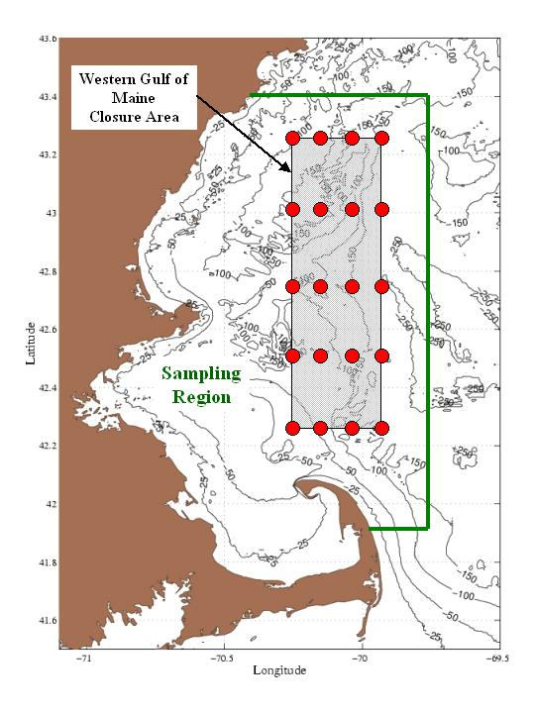
Fig. 6 – Western Gulf of Maine Closure Area and sampling region.
Two quasi-synoptic biological sampling surveys, at the beginning and midpoint of each experiment, will be carried out with Bongo nets for cod and neuston nets for lobster. Each survey will consist of 20 samples. The beginning survey will be carried out on the regular grid shown on Fig. 6. The midpoint survey will include the northern, middle and southern sections of 4 stations each but the intermediate 8 samples will be adapted to optimize the biological information relative to the pattern of physical currents and eddies known to be present at the time. Two trawlers should be expected to carry out the biological sampling within a week, doing one section (or equivalent) and associated CTD sampling within a 12 hr day.

The physical sampling will include three quasi-synoptic mesoscale resolution regional CTD (with fluorometry) surveys with dedicated vessels: an initialization survey, a midpoint survey and a final survey. The final survey will insure reasonably uniform accuracy throughout the duration of the experiment, utilized for smoothing data assimilation. Each survey will involve 3-5 vessels and is expected to be carried out within 4-7 days. The spatial resolution will be nominally 10 km along track in the closure area and its vicinity and in Mass and Cape Cod Bays.

Special features will be adaptively sampled at higher resolution. In the WGoM, the nominal sampling will be 10-20 km. Updating assimilation data will be obtained between the surveys by vessels of opportunity with also some dedicated vessels days to maintain accurate coverage throughout the duration of each experiment. Detailed sampling will be guided by the intensive data set of ASCOT-01 and the near real-time circulation simulations of the physics.

5.2.2 Biological sampling and analysis
The Northeast Fisheries Science Center will provide training to participants in the use of CTDs and plankton sampling gear. Training will also be provided in the sorting of plankton samples for identification of the target species for this project. Two bongo nets and two neuston nets will be provided by NEFSC for the sampling and in the event of problems with any of the CTD units purchased for this study, NEFSC will provide backup units as available.

Because research will be conducted in closed areas in the Gulf of Maine, a permit to do so will need to be obtained from the National Marine Fisheries Service. Dr. Fogarty at the Northeast Fisheries Science Center will assist MFP staff in securing all requisite permits necessary to undertake this research. Participating fishermen will use Days-At-Sea only on opportunistic sampling days and will land their catch using standard fishing gear which will not result in an increase of by-catch mortality. On dedicated research days, the fishermen will not use Days-At-Sea and will not catch or land any fish since cod ends will not be attached to the trawl nets. These nets will be deployed only to take measurements. The use of CTDs and plankton nets will also not result in by-catch mortality.

Samples from the neuston and bongo plankton nets provided by NMFS will be used to enumerate the abundances of American lobster and Atlantic cod larvae. To ensure compatibility with NMFS data, training for the identification of these specimens will be provided by NMFS. The use of bongo nets affords the opportunity to deploy two different mesh sizes: 333 micrometer mesh will capture fish larvae and larger zooplankters and 125 micrometer mesh will capture smaller zooplankton. At this time resources have not been identified that allow for more complete analyses of the plankton collected in the course of this project. However, the samples will be archived, and if during the course of the full data analysis it appears as if key questions might be addressed with information contained in these samples then resources will be sought to use either the off-shore counting facility employed by NMFS or another that we used for ASCOT-01 plankton samples. The fluorescence sensors on the CTDs will be calibrated with discrete samples for chlorophyll analysis and these calibrations will be used to estimate vertical distributions of chlorophyll over the sampling area.

PERSONNEL AND AVAILABLE RESOURCES
The MFP and Harvard University (HU) will lead and manage the research effort, ensuring proper dissemination of results and deliverables to end-user partners. The MFP will manage participation of the fishing vessels and administer the grant. The HU team will coordinate and lead the scientific research, including the real-time scientific forecasting and planktonic sampling. Dr. Michael Fogarty will be the contact at the Northeast Fisheries Science Center and will help secure the necessary permits for this research. In addition, he will provide sampling gear, training, and intercalibrations to ensure that data collected during the course of this study are directly intercomparable with those generated by NMFS.

The MFP is an umbrella organization of 18 commercial fishing associations representing all gear and geographic sectors of the Massachusetts fishing industry. The organization was created to promote common interests and economic viability of commercial fishermen and fishing families. David Bergeron, Executive Director, has more than ten years of experience in working with the commercial fishing fleet in Massachusetts. He is expert at building coalitions and managing both small and complex grants. He also administers member and outreach services for the Fishing Partnership Health Plan that provides coverage for 2,100 fishing community members. Olivia Free, Collaborative Research Coordinator, has developed and managed numerous restoration and research projects ranging from salmon habitat restoration to selective gear development to species studies. For the past three years, she has coordinated cooperative projects in New England and has worked with commercial fishermen to develop and implement these endeavors.

Prof. Allan R. Robinson is the Gordon McKay Research Professor of Geophysical Fluid Dynamics at Harvard University. His contributions include the dynamics and modeling of ocean currents, and the influence of physical processes on biological dynamics in the ocean. He is recognized as one of the pioneer and leading experts in modern ocean prediction and has contributed significantly to techniques for the assimilation of multiscale and interdisciplinary data into ocean-forecasting models. Prof. Robinson has served on numerous national and international advisory committees and chaired many programs for international cooperative science. He has authored and edited nearly two hundred research articles and books and is editor-in-chief of THE SEA and Dynamics of Atmospheres and Oceans.

Dr. Pierre Lermusiaux obtained an Ir./B. in Eng. from Liege University in 1992 and a Ph.D. in Engineering Sciences from Harvard in 1997, where he is a Research Associate in the Division of Engineering and Applied Sciences. He has held Fulbright Foundation Fellowships, was awarded the Wallace Prize at Harvard in 1993, and presented the Ogilvie Young Investigator Lecture in Ocean Engineering at MIT in 1998. His research interests include physical and physical-biogeochemical-acoustical ocean dynamics. He has been a reviewer for 12 scientific journals and has published more than 25 refereed manuscripts.

Prof. James J. McCarthy is Alexander Agassiz Professor of Biological Oceanography and Head Tutor for degrees in Environmental Science and Public Policy at Harvard University. He recently completed a two-decade term as the Director of Harvard University's Museum of Comparative Zoology. His research interests relate to the regulation of plankton productivity in the sea, in particular the cycling of nitrogen in planktonic ecosystems. He was the founding editor of Global Biogeochemical Cycles. For the recently completed third assessment of the Intergovernmental Panel on Climate Change (IPCC), he headed Working Group II, which had responsibilities for assessing impacts of and vulnerabilities to global climate change. He is a lead author on the Arctic Climate Impact Assessment.

Dr. Michael J. Fogarty is a Senior Scientist at the Northeast Fisheries Science Center, Woods Hole, MA. He holds adjunct appointments at the Woods Hole Oceanographic Institution, Univ. of Rhode Island, Univ. of Massachusetts and Univ. of Maryland. He has served on many national and international panels and committees including the Scientific Steering Committee of the U.S. GLOBEC program that he chaired from 1997-2002, and Global Ocean Observation System (GOOS) Steering Committee, and Coastal Observations Panel of GOOS. His current responsibilities include serving as Program Director for Ecosystem-Based Management at the Northeast Fisheries Science Center. His research interests center on the ecosystem effects of fishing and the role of climate change in marine ecosystem dynamics.

DISSEMINATION OF RESULTS, IMPACTS AND END USERS
The results of this project will be posted on the MFP website and Harvard website and submitted to the NEC’s Fisheries and Oceans Database. They will also be discussed at a plenary meeting of the FISHER Initiative, a collaboration of fishermen and scientists working together to establish a scientific foundation to promote ecosystem-based management through collaborative research. News releases will be sent out including articles in the MFP newsletter Waypoints distributed to 5000 fishermen in Massachusetts. Presentations will be made to the New England Fishery Management Council, the Stellwagen Bank National Marine Sanctuary, and other interested public and private organizations.

Results of this project directly address the need of management to evaluate the biological effectiveness of closed areas. This is very important in the evaluation of proposals of Marine Protected Areas and other forms of fisheries management. Since the NMFS Northeast Fisheries Science Center is involved in the project, the progress of the research will more closely facilitate ongoing development of new approaches to management at the Science Center, the New England Fishery Management Council and the Stellwagen Bank National Marine Sanctuary, including efforts to promote ecosystem-based approaches to management.

The end users of this project’s findings maps are numerous. Federal and state regulators, the New England Fishery Management Council, Governor Romney’s on-going implementation of recommendations from the Massachusetts Ocean Management Task Force, academic researchers, governmental researchers, student researchers, the commercial fishing industry, the recreational fishing industry, and the general public will benefit from this effort to characterize and predict physical transport processes with direct implications for understanding pathways of replenishment from closed areas to regions open to fishing in the WGoM.

LITERATURE CITED
Besiktepe, S.T., P.F.J. Lermusiaux and A.R. Robinson, 2003. Coupled physical and biological data driven simulations of Mass Bay in late summer: Real-time and post-cruise data assimilation. J. Mar. Sys., 40, 171-212.
Bogden, P.S., P. Malanotte-Rizzoli and R.P. Signell, 1996. Open-ocean boundary conditions from interior data: Local and remote forcing of Massachusetts Bay. J. Geophys. Res., 101, (C3), 6487-6500.
Brown, W.S., 1998. Wind-forced pressure response of the Gulf of Maine. J. Geophys. Res., 103, (C13), 30661-68.
Fogarty, M.J., J. Bohnsack, and P. Dayton, 2000. Marine reserves and resource management. In Seas at the Millennium: An Environmental Evaluation. (C. Sheppard, Ed.). Elsevier, Ch. 134. pp. 283-300.
Fogarty, M.J. and S.A. Murawski, 2005. Do marine protected areas really work? Oceanus 43:42-44.
Geyer, W.R., G.B. Gardner, W.S. Brown, J. Irish, B. Dutman, T. Loder and R.P. Signell, 1992. Physical oceanographic investigation of Mass. and Cape Cod Bays. Report to the Mass. Bays Progr. MBP-92-03., 497 pp.
Harding, G.C., K.F. Drinkwater, C.G. Hannah, J.D. Pringle, J. Presna, J.W. Loder, S. Pearre, Jr., and W.P. Vass. Larval lobster (Homarus americanus) distribution and drift in the vicinity of the Gulf of Maine offshore banks and their probable origins. Mar. Ecol. Prog.. Ser. In press.
Lawton, R., E. Kouloheras, P. Brady, W. Sides, and M. Borgatti. 1982. Distribution and abundance of larval American lobsters, Milne-Edwards, in the western inshore region of Cape cod Bay, Massachusetts. NOAA Tech. Rept. NMFS SsRF-775: 47-52.
Lermusiaux, P.F.J., 2001. Evolving the Subspace of the Three-Dimensional Multiscale Ocean Variability: Massachusetts Bay. J. Mar. Sys., 29, 385-422.
Lermusiaux, P.F.J., A.R. Robinson, P.J. Haley, Jr. and W.G. Leslie, 2002. Advanced interdisciplinary data assimilation: Filtering and smoothing via ESSE. Proc .Oceans 2002 IEEE/MITS Conf., 795-802.
Murawski, S.A., R. Brown, H.L. Lai, P. Rago and L. Hendrickson, 2000. Large-scale closed areas as a management tool in temperate systems: the Georges Bank experience. Bull. Mar. Sci. 66:775-798.
Murawski, S., P. Rago, and M. Fogarty, 2004. Spillover effects from temperate marine protected areas. Am. Fish. Soc. Symp. 42:167-184.
Murawski, S., S.E. Wigley, M.J. Fogarty, P.J. Rago, and D.G. Mountain, 2005. Effort distribution and catch patterns adjacent to temperate MPAs. ICES J. Mar. Sci. in press.
Robinson, A.R., 1999. Forecasting and Simulating Coastal Ocean Processes and Variabilities with HOPS, Coastal Ocean Prediction, (C.N.K. Mooers, Ed.), AGU Coastal and Estuarine Studies Series, 77-100.

Robinson, A.R. and the LOOPS Group, 1999. Real-time Forecasting of the Multidisciplinary Coastal Ocean with the Littoral Ocean Observing and Predicting System (LOOPS). Third Conference on Coastal Atmospheric and Oceanic Prediction and Processes, (3-5 Nov. 1999), New Orleans, LA. American Meteo. Society, 130-135.
Robinson, A.R. and P.F.J. Lermusiaux, 2002. Data Assimilation for Modeling and Predicting Coupled Physical-Biological Interactions in the Sea. THE SEA:Volume 12:Biological-Physical Interactions in the Sea. Robinson, A.R., J.J. McCarthy and B.J. Rothschild (Eds.), John Wiley and Sons, NY, 475-536.
Robinson, A.R. and P.F.J. Lermusiaux, 2003. Prediction Systems with Data Assimilation for Coupled Ocean Science and Ocean Acoustics, Proc. Sixth Intern. Conf. Theoretical Comp. Acoustics (A. Tolstoy et al Eds.). World Scientific Publishing (in press).
Signell R.P., H.L Jenter and A.F. Blumberg, 1993. Modeling the seasonal circulation in Massachusetts Bay. Estuarine and Coastal Modeling III., Proc. of the 3rd International Conference, sponsored by Waterway, September, 1993, Oak Brook, IL.
Warn-Varnas A., S.A. Ching-Bing, D.B King, Z.R. Hallock, and J. Hawkins, 2003. "Ocean-Acoustic Soliton Studies and Predictions, Reviews of Geophysics, Vol. 62, 39.

BUDGET (see attached)

BUDGET JUSTIFICATION
For the period January 1, 2006 - June 30, 2007, we request funding support of $279,574 to be distributed as follows:

Vessels/fishermen Instruments and Sensors
We have contacted and received quotes from more than 15 companies on sensors that could be utilized for this project. Based on the information currently collected, we plan to purchase:
  - 2 to 4 CTD systems
  - 14 mini-sensors (CTD)
  - 2 to 4 laptop computers for use aboard vessels to record and transfer the ocean data to shore

Based on NMFS experience, for dedicated sampling, SeaBird CTDs with fluorometry will be acquired. These CTDs will be purchased by the MFP and will be retained after this project to support other research efforts by the MFP fleet. For opportunistic sampling, the DST CTD min-sensor of Staroddi is the best solution. In addition, several fishermen have already used these sensors. Workshops will be held to familiarize the fishermen with the equipment, including installations on the vessels.

Vessels/fishermen sampling rates
The rate for dedicated sampling days is budgeted at $1,500 to $2,000 plus $500 for fuel per vessel for a 12h day, with the total amount being a function of vessel size and instrumentations. Each vessel will be chartered for 4 days of dedicated research. For a sustained 5-month period, 2 dedicated trips will be undertaken per week. In addition, fishermen will undertake opportunistic sampling during their normal courses of fishing at a rate of $50 per sample for a minimum of 4 samples per day. Active fishing periods will favor opportunistic sampling while low or no-fishing periods will favor dedicated trips. Lastly, one trawler and one lobster boat will be chartered for one day on which NMFS staff will conduct equipment training for the participating fishermen.

MFP
The MFP will oversee the grant, organize and manage the participation of the fishing fleet, and ensure proper dissemination of results and deliverables to end-user partners. Specifically, David Bergeron will undertake project oversight and administration and provide a link with the MFP board, the FISHER Initiative and other fishing community organizations to broaden participation in discussions as well as next steps to build on this research. Olivia Free will manage the participation of the fishing vessels including logistics, administration, and troubleshooting of issues as they arise. In addition, she will coordinate both a kick-off meeting to ensure that participants understand their roles and a final meeting at the conclusion of the project to debrief and solicit feedback on project processes and results. She will also assist with the coordination of training fishermen to use the necessary scientific equipment for this project. Lastly, she will assist with the preparation of progress and final reports, will help coordinate site visits by project monitors as needed, and will post project information on the MFP website and the Northeast Consortium’s Fisheries and Ocean Database to present timely project findings and results.

HU Sampling, Modeling and Predicting
The HU team will be responsible to carry out the real-time forecasting. Allan Robinson and Pierre Lermusiaux will lead and coordinate the scientific research, including the real-time scientific forecasting. Importantly, the actual cost for the ocean prediction and data assimilation is about 5 times as much as budgeted. James McCarthy will lead and coordinate the planktonic sampling and analysis. The HU effort is leveraged on other funds.
RESUMES OF KEY PARTICIPANTS

CURRICULUM VITAE
ALLAN R. ROBINSON
GORDON MCKAY RESEARCH PROFESSOR
OF GEOPHYSICAL FLUID DYNAMICS
HARVARD UNIVERSITY

Education:
B.A. Physics Harvard University 1954
M.A. Physics Harvard University 1956
Ph.D. Physics Harvard University 1959

Current Positions and Activities:
1968 – Gordon McKay Research Professor of Geophysical Fluid Dynamics, Division of Engineering and Applied Sciences, Department of Earth and Planetary Sciences, Harvard University
1997 – Distinguished Senior Fellow in the School for Marine Science and Technology, University of Massachusetts, Dartmouth
1994 – Chairman, Coastal Ocean Advanced Science and Technology Studies (COASTS) Steering Committee, Intergovernmental Oceanographic Commission/Scientific Counsel for Oceanographic Research, IOC/SCOR
1997 - External Board of Advisors, School for Marine Science and Technology, University of Massachusetts, Dartmouth
1976 – Editor-in-Chief, Dynamics of Atmospheres and Oceans
1994 – Editor-in-Chief, THE SEA: Ideas and Observations on Progress in the Study of the Seas

PUBLICATIONS – Recent:

184. 2003 – A Study of Environmental Indicators and the Predictability of Commercial Fish Stocks. ICES Marine Science Symposia - Hydrobiological Variability in the ICES Area, 1990-1999, 290 396-399.
Sundermeyer, M.A., B.J. Rothschild, and A.R. ROBINSON

183. 2003 – Prediction Systems with Data Assimilation for Coupled Ocean Science and Ocean Acoustics. Preceedings of the Sixth International Conference on Theoretical and Computational Acoustics (A. Tolstoy, et al., editors), World Scientific Publishing.
A.R. ROBINSON and P.F.J. Lermusiaux

182. 2003 – Advanced Systems for Operational Ocean Forecasting of Interdisciplinary Fields and Uncertainties. Proceedings of the MREP2003 Conference. (R. Tyce, editor), SACLANTCEN.
A.R. ROBINSON and W.G. Leslie

181. 2003 – Feature Oriented Regional Modeling and Simulations (FORMS) In the Gulf of Maine and Georges Bank, Continental Shelf Research, 23(3-4), 317-353.
A. Gangopadhyay, A.R. ROBINSON, P.J. Haley, Jr., W.G. Leslie, C.J. Lozano and J.J. Bisagni

180. 2003 – Data-driven Simulations of Synoptic Circulation and Transports in the Tunisian-Sardinia-Sicily Region. Journal of Geophysical Research, 108(C9), 8123-8135.
R. Onken, A.R. ROBINSON, P.J. Haley, Jr. and L.A. Anderson

179. 2003 – Real-Time Forecasting of Synoptic Transients in the Eastern Ligurian Sea.
E. Bovio, R. Tyce and H. Schmidt (Editors), Autonomous underwater vehicle and ocean modeling networks: GOATS 2000. Proceedings of a conference held in La Spezia, Italy, NATO SACLANT Undersea Research Centre, SACLANTCEN Conference Proceedings Series CP-46, 249-273.

A.R. ROBINSON, J. Sellschopp, W.G. Leslie, R. Onken, A. Alvarez, G. Baldasserini, P.J. Haley, Jr., P.F.J. Lermusiaux, C. Lozano, E. Nacini, R. Stoner, P. Zanasca

178. 2003 – Coupled physical and biological data-driven simulations of Massachusetts Bay in late summer: Real-time and post-cruise data assimilation. Special Issue on “The use of data assimilation in coupled hydrodynamic, ecological and bio-geochemical models of the oceans,” M. Gregoire, P.F.J. Lermusiaux and P. Brasseur (Editors), Journal of Marine Systems, 40-41, 171-212.
S.T. Besiktepe, P.F.J. Lermusiaux and A.R. ROBINSON

177. 2002 – Transfer of uncertainties through physical-acoustical-sonar end-to-end systems: A conceptual basis. Acoustic Variability 2002. N.G. Pace and F.B. Jensen (Editors), Saclantcen. Kluwer Press, 603-610.
A.R. ROBINSON, P. Abbot, P.J.F. Lermusiaux and L. Dillman

176. 2002 – Predictive Skill, Predictive Capability and Predictability in Ocean Forecasting. Proceedings of Oceans 2002 IEEE/MITS Conference, 787-794.
ROBINSON, A.R., P.F.J. Lermusiaux, P.J. Haley, Jr. and W.G. Leslie

175. 2002 – Advanced Interdisciplinary Data Assimilation: Filtering and Smoothing via Error Subspace Statistical Estimation. Proceedings of Oceans 2002 IEEE/MITS Conference, 795-802.
P.F.J. Lermusiaux, A.R. ROBINSON, P.J. Haley, Jr., and W.G. Leslie

174. 2002 – Coupled 3D Physical and Biological Modeling of the Mesoscale Variability Observed in NEA in Spring 1997: Biological Processes. Deep-Sea Research Part I: Oceanographic Research, 49(10), 1741-1768.
E.E. Popova, C.J. Lozano, M.A. Srokosz, M.J.R. Fasham, P.J. Haley, Jr. and A.R. ROBINSON

173. 2002 – Feature Oriented Regional Modeling of Oceanic Fronts, Dynamics of Atmospheres and Oceans. A. Gangopadhyay and A.R. ROBINSON

172. 2002 - Modeling Uncertainties in the Prediction of the Acoustic Wavefield in a Shelfbreak Environment. Theoretical and Computational Acoustics, 2001. Shang, E.-C., Q. Li and T.F. Gao (editors), World Scientific Publishing Co., 2002, 191-200.
P.F.J. Lermusiaux, C.-S. Chiu and A.R. Robinson

171. 2002 – Rapid Assessment of the Coastal Ocean Environment. Ocean Forecasting: Conceptual Basis and Applications, N. Pinardi & J.D. Woods (editors), Springer, 203-232.
A.R. ROBINSON and J. Sellschopp

170. 2002 – THE SEA: Biological-Physical Interactions in the Sea (A.R. ROBINSON, J.J. McCarthy and B.J. Rothschild, editors), Volume 12, John Wiley and Sons, New York, NY.
A.R. ROBINSON, J.J. McCarthy and B.J. Rothschild (editors)

169. 2002 – Introduction – Biological-Physical Interactions in the Sea: Emergent Findings and New Directions. THE SEA: Biological-Physical Interactions in the Sea (A.R. ROBINSON, J.J. McCarthy and B.J. Rothschild, editors), Volume 12, 1-17, John Wiley and Sons, New York, NY.

J.J. McCarthy, A.R. ROBINSON and B.J. Rothschild

168. 2002 – Data Assimilation for Modeling and Predicting Coupled Physical-Biological Interactions in the Sea. THE SEA: Biological-Physical Interactions in the Sea (A.R. ROBINSON, J.J. McCarthy and B.J. Rothschild, editors), Volume 12, 475-536, John

167. 2001 – Mediterranean Sea Circulation. Encyclopedia of Ocean Sciences. Academic Press Ltd., London, 1689-1706.
A.R. ROBINSON, A. Theocharis, A. Lascaratos and W.G. Leslie

166. 2001 – Assimilating near-real-time fisheries and environmental data in a advanced fisheries management information system (abstract), 2001 ICES AC Handbook, Annual Science Conference, International Council for the Exploration of the Sea, Oslo, 26-29 October.
W.S. Brown, F.L. Bub, B. Rothschild, M. Sundermeyer, A. Gangopadhyay, R. Lane, A.R. ROBINSON, and P.J. Haley, Jr.

165. 2001 – Data Assimilation in Models. Encyclopedia of Ocean Sciences. Academic Press Ltd., London, 623-634.
A.R. ROBINSON and P.F.J. Lermusiaux

164. 2001 – On the Summer Mesoscale Variability of the Black Sea. Journal of Marine Research, 59 475-515.
S.T. Besiktepe, C.J. Lozano and A.R. ROBINSON

7-06-04
Pierre F. J. Lermusiaux
Research Associate, Division of Engineering and Applied Sciences, Harvard University,
Pierce Hall G2A, 29 Oxford Street, Cambridge, MA 02138-2901
Phone: (617) 495-0378, Fax: (617) 495-5192
Email: pierrel@pacific.deas.harvard.edu, Web: http://ww.deas.harvard.edu/~pierrel

Professional Background
2000 - Research Associate, Div. of Engineering and Applied Sciences
1997-99 Post-Doctoral Fellow, Div. of Engineering and Applied Sciences
1999 Visiting Scholar, February 1999, IMGA-ISAO, CNR, Bologna Univ., Italy
1992-97 Research Assistant, Div. of Engineering and Applied Sciences
1994 Summer Research Assistant, NATO Undersea Research Center, La Spezia, Italy
1992 Summer Research Assistant, Paris VI Univ., Orsay, France
Education
1992 Ir./ B. Eng – Mechanics-Physics – Liege University
1993 S.M. Applied Physics – Harvard University
1997 PhD Engineering Sciences – Harvard University
Awards and Honors
CIMAS Visiting Scientist, School of Marine and Atmospheric Science, U. of Miami, 2002
Annual T. Francis Ogilvie Young Investigator Lecture, Ocean Engineering, MIT, 1998
Honorary Fellow, Fulbright Foundation, 1992-97
Honorary Fellow, Belgian American Education Foundation, 1992-97
Fellow, Fulbright Foundation, 1993-1996
Fellow, Robert L. Wallace Price Fellowship from Harvard University, 1993
Fellow, Jury Pisard English Foundation of Liege Univ. (at Mc Master Univ., Canada)
Fellow, Rotary Exchange Program, Hamilton, Canada, 1986

Biography/Research Interests
Dr. Pierre Lermusiaux obtained a Ir./B. in Eng. (summa plus) from Liege University in 1992 and a Ph.D. in Engineering Sciences from Harvard in 1997, where he is a Research Associate in the Division of Engineering and Applied Sciences. He has held a Fulbright Foundation Fellowship, was awarded the Wallace Prize at Harvard in 1993, and presented the Ogilvie Young Investigator Lecture in Ocean Engineering at MIT in 1998. His current research interests include physical and interdisciplinary ocean dynamics, from sub-mesoscales to interannual scales. They involve physical-biogeochemical-acoustical ocean modeling, optimal estimation and data assimilation, uncertainty and error modeling, and the optimization of observing systems. He has been working closely with undergraduate and graduate students and post-docs in DEAS at Harvard. He participated in various at-sea experiments and collaborated with ocean scientists and engineers from several institutions. He has more than 25 refereed publications.

Five Relevant Recent Publications:
- Lermusiaux, P.F.J., C. Evangelinos, R. Tian, P.J. Haley, J.J. McCarthy, N.M. Patrikalakis, A.R. Robinson and H. Schmidt, “Adaptive Coupled Physical and Biogeochemical Ocean Predictions: A Conceptual Basis”, Computational Science - ICCS’2004 F. Darema et al., Editors. Lecture Notes in Computer Science, 2004. 3038, 685-692.
- Besiktepe, S.T., P.F.J. Lermusiaux and A.R. Robinson, “Coupled physical and biogeochemical data driven simulations of Massachusetts Bay in late summer: real-time and post-cruise data assimilation”, Special issue on The use of data assimilation in coupled hydrodynamic, ecological and biogeochemical models of the oceans, M. Gregoire, P. Brasseur and P.F.J. Lermusiaux (Eds.) J. of Mar. Sys., 40–41, 171–212, 2003.
- Lermusiaux, P.F.J., A.R. Robinson, P.J. Haley and W.G. Leslie, 2002. Advanced interdisciplinary data assimilation: Filtering and smoothing via Error Subspace Statistical Estimation. Proceedings of “The OCEANS 2002 MTS/IEEE” conference, Holland Publications, 795-802.
- Robinson A.R. and P.F.J. Lermusiaux, “Data assimilation for modeling and predicting coupled physicalbiological interactions in the sea”, In The Sea, Vol. 12: Biological-Physical Interactions in the Ocean, A.R. Robinson, J.J. McCarthy and B.J. Rothschild (Eds.) pp. 475–536, 2002.
- P.F.J. Lermusiaux, “Evolving the subspace of the three-dimensional multiscale ocean variability: Massachusetts Bay”, J. Marine Systems, Special issue on Three-dimensional ocean circulation: Lagrangian measurements and diagnostic analyses, 29/1–4, 385–422, 2001.

Five Other Recent Publications:
- Robinson A.R. and P.F.J. Lermusiaux, “Prediction Systems with Data Assimilation for Coupled Ocean Science and Ocean Acoustics”, Proceedings of the 6th Intn’l Conf. on Theoretical and Computational Acoustics (A. Tolstoy, et al., eds.), World Sc. Pub., 2004. In press.
- Evangelinos, C., P.F.J. Lermusiaux, R.C. Chang, S. Geiger and N.M. Patrikalakis, “Web-Enabled Con figuration and Control of Legacy Codes: An Application to Ocean Modeling”, Ocean Modeling, 2005. Submitted.
- Onken, R., A.R. Robinson, P.F.J. Lermusiaux, P.J. Jr. Haley and L.A. Anderson, “Data-driven simulations of synoptic circulation and transports in the Tunisia-Sardinia-Sicily region”, J. of Geophysical Research, 108, (C9), 8123–8136, 2003.
- Lermusiaux, P.F.J., 2002. On the mapping of multivariate geophysical fields; sensitivity to size, scales and dynamics. J. of Atmos. Oceanic Tech., 19, 1602-1637.
- Lermusiaux P.F.J. and A.R. Robinson, “Features of dominant mesoscale variability, circulation patterns and dynamics in the Strait of Sicily”, Deep Sea Res., 48, (9), 1953–1997, 2001.

Editorial Board: International Journal of Ocean and Oceanography

Reviewer for: JGR-Oceans, Mon. Wea. Rev., J. of Marine Res., Dyn. of Atmos. and Oceans, J. of Mar. Sys., J. of Atmos. and Ocean. Tech., IEEE J. of Ocean. Eng., Tellus, J. of the Acous. Soc. of Amer., Deep-Sea Res. II, Fisheries Ocean., J. of Phys. Ocean., J. Mar. and Freshwater Res. NSF, NOPP.

Member of: Assoc. des Ingenieurs de Liege, Royal Meteo. Society, American Geophys. Union, The Oceanography Society, Who’s Who in America, Who’s Who in Science and Engineering, Monitoring Science Advisory Panel for Mass. EPA.

Collaborators and Other Affiliations
• Collaborators within the last 48 months: Harvard U. - A.R. Robinson, J. McCarthy; W.G. Leslie P.J. Haley, R. Tian, D.G.M. Anderson, R.W. Brockett; MIT - W. Cho, C. Evangelinos, H. Schmidt, N. Patrikalakis; Scripps - B. Cornuelle, R. Davis; Rutgers U. - H.G. Arango; UMass at Darmouth - A. Gangopadhyay; Oasis Inc. - P. Abbot; SACLANTCEN, Italy - E. Coehlo, M. Rixen, R. Onken; U. of Mississippi - A. Warn-Varnas; Woods Hole – G. Gawarkiewicz, D. Fratantoni, J. Lynch, T. Duda; UC-Santa Cruz - S. Djurcilov, K. Kim, A. Pang; Oregon State U. - B. Miller; NPS - C.-S. Chiu; S. Ramp; MBARI - J. Bellingham; JPL: Yi Chao; Princeton U.: N. Leonard; U. Miami: S. Majumdar; Cal. Tech.: J. Marsden.
• Graduate and Postgraduate Advisor: Prof. A.R. Robinson, Harvard University.
CURRICULUM VITAE

Prof. James J. McCarthy

Museum of Comparative Zoology, Harvard University, 26 Oxford St., Cambridge, MA 02138. Ph (617)495-2330; Fax (617)495-0506; jmccarthy@oeb.harvard.edu

PROFESSIONAL PREPARATION
Gonzaga University, Biology, B.S. 1966
Scripps Institution of Oceanography, UC San Diego, Biological Oceanography, Ph.D. 1971
APPOINTMENTS (Harvard only)
Head Tutor, Environmental Science and Public Policy, Harvard University (1996- )
Alexander Agassiz Professor of Biological Oceanography, Harvard University (1980- )
Faculty of Department of Organismic and Evolutionary Biology, Harvard University (1974- )
Director of the Museum of Comparative Zoology, Harvard University (1982-2002)
Associate Dean, Faculty of Arts and Sciences, Harvard University (1986-90)
Assistant and Associate Professor, Harvard University (1974-1980)

PUBLICATIONS
Five Publications Most Relevant to the Proposed Research
McCarthy, J.J., A.R. Robinson, B. J. Rothschild (2001), Biological-Physical Interactions in the Sea: Emergent Findings and New Directions. Chapter 1, in The Sea, Vol. 12. , Biological – Physical Interactions in the Sea, Robinson, A.R., J. J. McCarthy, and B.J. Rothschild, Eds., John Wiley & Sons, Inc. 634pp.
McCarthy, J.J., C. Garside and J.L. Nevins(1999), Nitrogen Dynamics during the Arabian Sea Northeast Monsoon. Deep Sea Res., 46: 1623-1664.
McCarthy, J. J. (2001), Biological Reponses to Nutrients. Chapter 6, in The Sea, Vol. 12, Biological – Physical Interactions in the Sea, Robinson, A.R., J. J. McCarthy, and B.J. Rothschild, Eds., John Wiley & Sons, Inc. 634pp.
Schrag, D.P., and J..J. McCarthy (2001), Biological-Physical Interactions and Global Climate Change: Some Lessons from Earth History. Chapter 15, in The Sea, Vol. 12, Biological – Physical Interactions in the Sea, Robinson, A.R., J. J. McCarthy, and B.J. Rothschild, Eds., John Wiley & Sons, Inc. 634pp.
McCarthy, J. J., O. F. Canziani, N.A. Leary, D. J. Dokken, and K.S. White, Eds. (2001). Climate Change 2001: Impacts, Adaptation, and Vulnerability. Published for the Intergovernmental Panel on Climate Change, Cambridge University Press. 1032pp.

Five Other Significant Publications
McCarthy, James J., M. Long Martello, R. Corell, N. Eckley, S. Fox., G. Hovelsrud-Broda, S. Mathiesen, C. Polsky, H. Selin, and N. Tyler, in press. “Climate Change in the Context of Multiple Stressors and Resilience.” In: Arctic Climate Impact Assessment.
Turner, B.L., R.E. Kasperson, P.A. Matson, J.J. McCarthy, R.W. Corell, L. Christensen, N. Eckley, J.X. Kasperson, A. Luers, M.L.Martello, C. Polsky, A. Pulsipher, A Schiller. A framework for volunerability analysis in sustainability science. Proceedings of the National Academy of Sciences, 100: 8074-8079.
Turner, B. L., P.A. Matson, J.J. McCarthy, R.W., Corell, L. Christense, N.Eckley, G.K. Hovelsrud-Broda, J.X. Kasperson, R.E. Kasperson, A. Luers, M.L. Martello, S. Mathiesen, R.Naylor, C. Polsky, A. Pulsipher, A. Schiller, H. Selin, N. Tyler. Illustrating the coupled human-environment system for vulnerability analysis: Three case studies. Proceedings of the National Academy of Sciences, 100: 8080-8085.
Kates, R.W., W.C. Clark, R. Corell, J.M. Hall, C.C. Jaeger, I. Lowe, J.J. McCarthy, H.J. Schellnhuber, B. Bolin, N.M. Dickson, S. Faucheux, G.C. Gallopin, A. Grübler, B. Huntley, J. Jäger, N.S. Jodha, R.E. Kasperson, A. Mabogunje, P. Matson, H. Mooney, B. Moore III, T. O'Riordan, and U. Svedlin (2001), Sustainability Science. Science, 292: 641-642.
McCarthy, J.J. (1999), The evolution of the Joint Global Ocean Flux Study project. In The Changing Ocean Carbon Cycle, Book 5, International Geosphere-Biosphere Programme Book Series. Ed. R.B.Hanson, H.W. Ducklow and J.G.Field. Cambridge University Press.

SYNERGISTIC ACTIVITIES
From 1986 to 1993 he was the first chair of the international committee that establishes research priorities and oversees implementation of the International Geosphere - Biosphere Program. He was the founding editor for the American Geophysical Union's Global Biogeochemical Cycles. For the Intergovernmental Panel on Climate Change (IPCC), he headed Working Group II, which had responsibility for assessing impacts of and vulnerabilities to global climate change in the recently completed Third Assessment. For the Arctic Climate Impact Assessment he is the lead author of the chapter that assesses interactions among multiple stresses in Arctic human-environment systems. At Harvard he helped to develop and currently directs the undergraduate degree program in Environmental Science and Public Policy.
COLLABORATORS AND OTHER AFFILIATIONS
Within the last 48 months, in addition to co-authors specifically listed in citations above there were two dozen authors in the volume of The Sea that I co-edited, and over 400 collaborating authors in the IPCC Working Group II book I co-edited. Particularly close collaborators in addition to those on this proposal are: W. Clark (Harvard Univ.), C. Garside (Bigelow), H. Ducklow (VIMS), Robert Kates (retired), R. Kasperson (Stockholm Environment Institute), N. Leary (START), M.C. McKenna (retired), P. Matson, R. Moss (Batelle), (Stanford Univ.), J. Murray (UW), N. Patrikalakis (MIT), A.R. Robinson (Harvard Univ.), B. Rothschild (U Mass), H. Schmidt (MIT), B. Turner (Clark Univ.), A. Yilmaz (METU, Turkey).

Graduate and Postgraduate Advisors: R. W. Eppley (Univ. of California), M.M. Mullin (Univ. of California – deceased), J.D.H. Strickland (Univ. of California – deceased), and W. R. Taylor (Johns Hopkins Univ. – deceased).

Thesis Advisor and Postgraduate-Scholar sponsor in last 5 years: S. Fox Gearheard (Harvard Univ.), J. Shoemaker (Harvard Univ.), P. Moreno (Harvard Univ.), N. Sheats (Environmental Defense). (8 Ph.D. students; 3 post-docs).

CURRICULUM VITAE
Michael J. Fogarty

Senior Scientist Telephone: (508)495-2386
Northeast Fisheries Science Center Fax: (508)495-2258
National Marine Fisheries Service E-Mail: michael.fogarty@noaa.gov
Woods Hole, MA 02543

PROFESSIONAL PREPARATION

University of Rhode Island, Zoology. Magna cum laude. B.S. 1973.
University of Rhode Island, Marine Ecology. MS. 1976
University of Rhode Island, Fishery Science. PhD.1986

APPOINTMENTS

Senior Scientist, Northeast Fisheries Science Center, National Marine Fisheries Service, Woods Hole, MA, 1999-present
Adjunct Professor of Environmental Science, University of Maryland Center for Environmental Science, Chesapeake Biological Laboratory, Solomons, MD, 1999-present
Adjunct Scientist, Woods Hole Oceanographic Institution, 2000-present
Associate Professor, The University of Maryland System, Center for Environmental Science, Chesapeake Biological Laboratory, Solomons, MD (On leave from NOAA) 1996-1999
Supervisory Fisheries Biologist/Research Fishery Biologist/Operations Research Analyst, Northeast Fisheries Science Center, National Marine Fisheries Service, Woods Hole, MA 1980-1996

Synergistic Activities (Last 5 Years)
Scientific Steering Committee for the U.S. GLOBEC Program (Chair 1997-2002)
Coastal Ocean Observation Panel of the Global Ocean Observing System
International Steering Committee for the Global Ocean Observing System
Fellow WHOI/NOAA Cooperative Institute for Climate and Ocean Research
Global Change and Fisheries Program of the Royal Society of Canada
U.S. Ocean Observing System Task Team
U.S. National Climate Assessment Working Group (Coastal and Marine Areas Sector)
Review Panel for CIMAS Program Rosenstiel School for Marine and Atmospheric Science
Scientific and Statistical Committee of the Mid-Atlantic Fishery Management Council.

5 Publications Related to this proposal
Fogarty, M. J. 1997. Implications of larval dispersal and directed migration in American lobster stocks spatial structure and resilience. Can. Spec. Publ. Fish. Aquat. Sci. 125:273-283.
Fogarty, M.J. 1999. Essential habitat, marine reserves, and fishery management. Trends in Ecol. Evol. 14:133-134.
Fogarty, M.J., J. Bohnsack, and P. Dayton. 2000. Marine Reserves and Resource Management. In Seas at the Millennium: An Environmental Evaluation (C. Sheppard, Ed.). Elsevier, Ch. 134. pp. 283- 300.
Murawski, S.A., P. Rago, and M.Fogarty 2004. Spillover effects from temperate marine protected areas. AFS Symp. Vol. 42:167-184
Fogarty, M.J. and S.A. Murawski. Do marine protected areas really work? Oceanus. In press.

5 Additional Publications
Fogarty, M.J. 2001. Dynamics of Exploited Marine Fish Populations. In (J.H. Steele, K.K. Turekian, and S.A. Thorpe , Eds.) Encyclopedia of Ocean Sciences, Academic Press, pp. 774-781.
Fogarty, M.J., R.A. Myers and K. Bowen.. 2001. Recruitment of cod and haddock populations in the North Atlantic: A comparative analysis. ICES J. Mar. Sci. 58:952-961 Fogarty, M.J. 2002. Climate variability and ocean ecosystem dynamics: implications for sustainability. In (W. Steffen, J. Jager, D.J. Carson, and C. Bradshaw, Eds.) Challenges of a Changing Earth. Proc. Global Change Open Science Conference, Amsterdam, The Netherlands, 10-13 July 2001. pp 27-29.
Murawski, S.A., S. Wigley, M.Fogarty, P. Rago, and D. Mountain. Effort distribution and catch patterns adjacent to temperate MPAs. ICES J. Mar. Sci., in press.
M.J. Fogarty and L.W. Botsford. Metapopulation biology of decapods. In (P. Sale and J., Kritzer, Eds.) Marine Metapopulation. In press.

Collaborators and Co-Editors (Past 48 Months)
James Bisagni, Univ. Massachusetts, Dartmouth, MA; Donald Boesch, Univ. Maryland Center for Environmental Science, Cambridge, MD; James Bohnsack, National Marine Fisheries Service, Miami, FL; Keith Bowen Dalhousie Univ., Halifax, NS; Robert Brock, National Marine Fisheries Service, Silver Spring, MD; John Brodziak, National Marine Fisheries Service, Woods Hole, MA; R.W. Buddemier, Kansas Geological Survey, Univ. Kansas; Virginia Burkett, National Wetlands Research Center, U.S. Geological Survey; Daniel Cayan Scripps Institute of Oceanography, LaJolla, CA; Paulinus Chigbu, Jackson State University, Jackson, MS; Jeremy Collie, Graduate School of Oceanography, URI, Narrangansett, RI,Paul Dayton, Scripps Institute of Oceanography, LaJolla, CA; Edward Durbin Graduate School of Oceanography, URI, Narrangansett, RI; Steven Edwards, National Marine Fisheries Service, Narrangansett, RI;; Michael Frisk Chesapeake Biological Laboratory, UMD, Solomons, MD; Lance Garrison, National Marine Fisheries Service, Miami, FL; Louise Gendron, Fisheries and Oceans Canada, Mont Joli, Quebec; Timothy Gerrodette, National Marine Fisheries Service, LaJolla, CA; Dian Gifford Graduate School of Oceanography, URI, Narrangansett, RI; John Hoenig, Virginia Institute of Marine Science, Gloucester Point, VA; Robert Howarth, Oceans Program, Environmental Defense Fund; Anne Hollowed National Marine Fisheries Service, Seattle, WA; Lewis Incze, Univ. Southern Maine, Portland, ME; Ambrose Jearld, National Marine Fisheries Service, Woods Hole, MA; Cynthia Jones. Old Dominion University, Norfolk, VA; John Jossi National Marine Fisheries Service, Narragansett, RI; Anthony Knapp, Bermuda Biological Station; Irving Kornfield, University of Maine, Orono, ME; Christopher Lage, University of Maine, Orono, ME; Richard Langton, Department of Marine Resources, Boothbay Harbor, ME; Jason Link, National Marine Fisheries Service, Woods Hole, MA; Romuald Lipcius, Virginia Institute of Marine Science, Gloucester Point, VA; Patricia Livingston, National Marine Fisheries Service, Seattle, WA; Seth Macinko, Univ. Connecticut, Storrs CT; Lawrence Madin, Woods Hole Oceanographic Institution, Woods Hole, MA, William Michaels National Marine Fisheries Service, Woods Hole, MA; Thomas Miller Chesapeake Biological Laboratory, UMD, Solomons, MD; David Mountain, National Marine Fisheries Service, Woods Hole, MA; Steven Murawski National Marine Fisheries Service, Woods Hole, MA; Ransom Myers, Dalhousie Univ., Halifax, NS; William Overholtz National Marine Fisheries Service, Woods Hole, MA; Debra Palka, National Marine Fisheries Service, Woods Hole, MA; John Pope, University of Oslo; Thomas Powell, Univ. California, Berkeley, CA; Margaret Purcell, University of Maine, Orono, ME; Jake Rice Fisheries and Oceans Canada, Nanaimo, Ottawa Ontario; Thomas Royer, Old Dominion University, Norfolk, VA; Donald Scavia, National Ocean Service, Silver Spring, MD; Michael Sieracki, Bigelow Laboratory for Ocean Sciences, Boothbay Harbor, ME; Timothy Smith, National Marine Fisheries Service, Woods Hole, MA; John Steele, Woods Hole Oceanographic Institution, Woods Hole, MA; Barbara Sullivan Graduate School of Oceanography, URI, Narrangansett, RI; Keith Thompson Dalhousie Univ., Halifax, NS; James Titus, Office of Economy and the Environment, Environmental Protection Agency; Richard Wahle, Bigelow Laboratory for Ocean Sciences, Boothbay Harbor, ME

Graduate Advisor
J. Stanley Cobb, University of Rhode Island, Kingston, RI
Thesis Advisor and Postgraduate-Scholar Sponsor
Michael Frisk, University of Maryland, Solomons MD (Thesis), Amanda Truett, University of Maryland, College Park, MD (Thesis); William Stockhausen, VIMS (Postgraduate Fellow)

David Bergeron

Executive Director

Massachusetts Fishermen's Partnership

2 Blackburn Center, Gloucester, MA 01930

Phone: 978-282-4847; Fax: 978-282-4798

dbergeron@mass-fish.org

www.mass-fish.org

Professional Experience

Massachusetts Fishermen's Partnership, Inc., Executive Director and founding member of the Board of Directors, January 1995 to present

Commonwealth Corporation Gloucester Fishermen and Families Assistance Center, Outreach Coordinator, June 1997 to November 2002

Gloucester Fishermen's Wives Assoc., Program Coordinator, June 1994 to May 1997

St. Ann Church, “The Church of the Fishermen,” Pastor's Assistant, August 1991 to November 1994

Gloucester Fishing Oral History Project, North Shore Employment Board, Project Leader, June 1994 to September 1994

Independent Christian Church Unitarian Universalist, Director of Music, September 1993 to present

Development Consultant/Fund Raiser, 1982 to 1993

Other Experience

Fishing Partnership Health Plan, Steering Committee, January, 1995 to 1998

Vision 2020 Fishing Community Strategic Plan, Coordinator, 1994 to 1998

Gloucester Human Rights Commission, Charter Member

Cape Ann Pediatric AIDS Fund, Founder, 1992

Cape Ann Pediatric AIDS Committee, Co-Founder, 1992

"heART Inspirations" Benefit and Pediatric AIDS Awareness Project for Cape Ann Children, Founder and Coordinator

Gloucester Columbus 500 Committee, a multi-cultural festival: "Re-
Discovering Gloucester & America", Chairman

Skills
- Organizational, program, and project management
- Political analysis and strategy
- Group facilitation, leadership and coordination
- Strategic planning
- Coalition building
- Public speaking
- Development planning, fund-raising and campaign consulting
- Budget preparation and tracking
- Grant, article and editorial writing
- World Wide Web publishing
- Media and public relations
- Public outreach and involvement programs

Education

Catholic University of America, Master Teacher Certificate in Music Education, Center for Ward Method Studies, Washington, DC, 1985

New England Conservatory, Master of Music in organ, Boston, MA, 1983

Private study with Jean Langlais in organ and improvisation, Paris, 1978-79

Alliance Française, license diploma, Paris, France, 1978-79

Stetson University School of Music, Bachelor of Music in organ, DeLand, FL, 1974-78
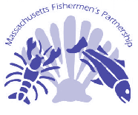
Olivia Free

Collaborative Research Coordinator

Massachusetts Fishermen's Partnership

2 Blackburn Center, Gloucester, MA 01930

Phone: 978-282-4847; Fax: 978-282-4798

olivia@mass-fish.org

www.mass-fish.org

Professional Experience

Massachusetts Fishermen's Partnership, Inc., Collaborative Research Coordinator, 2003-present

King County Department of Natural Resources, Water and Land Resources Division, Watershed Planning and Salmon Protection Program Analyst, Seattle, WA, 1999 – 2001

Triangle Associates, Inc., Research Associate, Seattle, WA, 1996 – 1998

Pacific Environment and Resources Center, Contract Environmental Research Writer, Sausalito, CA, 1994 – 1995

Environmental Defense Fund, Fundraising Consultant, Oakland, CA, 1994

Appalachian Mountain Club, Chapter and Member Relations Assistant, Boston, MA, 1993

Environmental Federation of New England, Program Development Coordinator, Boston, MA, 1992

Environmental Support Center, Inc., Assistant to the Executive Director, Washington, D.C., 1991-1992

Other Experience

Northeastern Massachusetts Aquaculture Center, Advisory Board, Salem, MA 2003

New England Aquarium, Volunteer Aquarist, Boston, MA, 2003

Earthwatch Institute and Conservation International, Volunteer Field Researcher, Pantanal, Brazil, 2002

Marine Mammal Center, Animal Care Staffperson, Marin, CA, 1994

Institute for Cultural Affairs, Group Facilitation Training, Seattle, WA, 1998

PADI certified SCUBA diver, 1995

Skills
- Program and project management
- Grant writing and management
- Public outreach and involvement programs
- Technical assistance
- Budget preparation and tracking
- Progress and final report preparation
- Fundraising
- Project prioritization
- Technical writing
- Coalition building
- Written and spoken French

Education

University of Pittsburgh, Master's Degree in Public and International Affairs and
Graduate Certificate of Environmental Management and Policy, Pittsburgh, PA 1995

Lafayette College, Bachelor of Arts, American Civilization Studies and Bachelor of Arts, French Language Studies, Easton, PA, 1990

Alliance Francaise, Diplome de Langue, Paris, France, 1989

DESCRIPTION OF PRIOR COOPERATIVE RESEARCH RESULTS AND IMPACTS
Allan Robinson has been chairman or co-chairman of numerous national and international research programs and committees including: POLYMODE, the US-USSR study of mesoscale eddy dynamics, POEM, the physical-biological study of the Eastern Mediterranean (U.S., Italy, Croatia, Greece, Turkey, Israel, and Egypt); International GLOBEC interdisciplinary numerical modeling group. He currently chairs the COASTS (Coastal Ocean Advanced Scientific and Technical Studies) program for IOC-UNESCO/SCOR. Together with James McCarthy he is a recognized pioneer in contemporary interdisciplinary ocean science. They co-direct interdisciplinary Ph.D. students and have edited (along with Brian Rothschild) Volume 12 of The Sea (Biological Physical Interactions in the Sea, Wiley 2002).

James McCarthy has been a member of and has chaired steering committees that have planned and implemented oceanographic and global change research and climate change assessment projects and programs. These include the Warm-Core Rings project in the Gulf Stream region during the early 1980s, the Joint Global Ocean Flux Program from the mid 80s to the mid 90s, the International Geosphere-Biosphere Programme from the mid 80s to the mid 90’s, the Intergovernmental Panel on Climate Change from the mid to late 90s, and the Arctic Climate Impact Assessment during the past five years. Each of these projects effected new interdisciplinary syntheses relating to ocean and environmental science. Together with Allan Robinson he is a recognized pioneer in contemporary interdisciplinary ocean science. They co-direct interdisciplinary Ph.D. students and have edited (along with Brian Rothschild) Volume 12 of The Sea (Biological Physical Interactions in the Sea, Wiley 2002)

Pierre Lermusiaux and Allan Robinson are currently participating in ONR multi-institution collaborative projects associated with: interdisciplinary adaptive sampling; undersea monitoring and surveillance; and coupled acoustical-physical data assimilation. They have an ongoing collaboration with NURC (NATO Undersea Research Center) on Deterministic and Stochastic Regional Forecasting.

David Bergeron is involved in the following on-going cooperative project:
- Institutionalizing Social Science Data Collection to demonstrate effective use of community-based panels to collect and analyze social science information and to make this information available to improve fisheries management. Findings from this work informed the Amendment 13 development process and is currently being utilized by the Gloucester Harbor Plan Committee.

David Bergeron and Olivia Free are involved in the following on-going cooperative projects:
- Charting Anecdotal Information and Oral Histories from Local Fishermen to demonstrate the collective effort of each gear type, the seasonal variations in target species and approximate fishing locales by digitizing anecdotal information provided by numerous commercial fishermen along the Massachusetts coast. This information will inform several on-going management processes such as the development of a five-year management plan for the Stellwagen Bank National Marine Sanctuary and the State’s Human Use Characterization project.
- An Examination of Biological Processes of Sand Lance and Associative Species on Stellwagen Bank to study the biological processes of sand lance to understand its role as a possible keystone species in the marine environment. This knowledge is important since many varied species such as cod, tuna, skates, whales, seals, and seabirds depend on sand lance as an important food source and their study is likely to reveal significant ecosystem patterns and relationships.
- Ecosystem Effects of Trawling on Groundfish Communities: Catch Composition and Food Web Dynamics With Respect to Long-Term and Rolling Closures on Stellwagen Bank to study the effects of bottom trawling on seabottom habitats and the combined multispecies effects of trawling (and other fishing methods) on the food webs that support local fisheries. The differences in fish community structure and food web dynamics that have accumulated during the five years since the Western Gulf of Maine Closure was made effective will be examined. This study will provide critical information for policy-making on the issues of rolling closures, permanent closures, and essential fish habitat.
- The Design and Preliminary Testing of an Innovative Scallop Dredge to develop a low-impact dredge based on diver observations of hydrodynamic lift to reduce bottom impacts during harvesting. Development of an efficient low-impact scallop dredge could lead to its adoption in the Massachusetts inshore scallop fleet or the much larger, offshore scallop fisheries on Georges Bank, Hudson Canyon, and the Mid-Atlantic region.
- Mapping Mobility: The Movement of New England Multispecies Vessels and Crew in New England and Beyond from 1994-2004 to examine how much boats and crew move from one harbor to another, and whether or not that has changed over time, to enable fisheries managers and others to better understand fishing communities and the challenges they face.

Current and Pending Support:
PROFESSOR ALLAN R. ROBINSON
Current
Dynamics of Oceanic Motion
ONR
$1,225,000
7/1/02-6/30/07
Harvard University
Person-months per year committed to the project: 7

Optimal Asset Distribution for Environmental Assessment and Forecasting Based on Observations, Adaptive Sampling, and Numerical Prediction
ONR
$705,890
5/1/04-4/30/09
Harvard University
Person-months per year committed to the project: 2

Persistent Littoral Undersea Surveillance Network (PLUSNet)
ONR
$1,000,000
5/6/05-9/30/07
Person-months per year committed to the project: 3

Pending
Sponsor: Northeast Consortium (Co-PI):
Dates: 07/01/05 - 06/30/07.
Title: Ecosystem Effects of Closed Areas in the Western Gulf of Maine.
Amount: (HU: $60,000).
Person Months Per year: 0
Location: Harvard University, Cambridge, MA

Sponsor: MIT under NSF Prime Award (Co-PI)
Dates: 9/15/05-9/14/08
Title: DDDAS-TMRP: Interdisciplinary Adaptive Modeling System for Estimation and Adaptive
Sampling (IAMSEAS)
Amount: (HU: $968,931)
Person Months Per year: 2 Calendar Months
Location: Harvard University, Cambridge, MA

PIERRE LERMUSIAUX
Current
Sponsor: MURI-ASAP (ONR, Co-PI):
Dates: 05/01/04 - 04/30/09.
Title: Optimal Asset Distribution for Environmental Assessment and
Forecasting Based on Observations, Adaptive Sampling and
Numerical Prediction. Multiple institutions.
Amount: (HU: $704,000).
Person Months Per year: 2 Calendar Months
Location: Harvard University, Cambridge, MA

Sponsor: ONR-Core (co-PI):
Dates: 10/01/04 - 09/30/07.
Title: Physical and Interdisciplinary Regional
Ocean Dynamics and Modeling Systems.
Amount: (HU: $360,311).
Person Months Per year: 6 Calendar Months
Location: Harvard University, Cambridge, MA

Sponsor: PLUSNet (ONR, Co-PI):
Dates: 01/01/05 - 12/31/07.
Title: Persistent Littoral Undersea Surveillance Network.
Amounts: (PLUSNet: $36,600,000; HU: $1,000,000).
Person Months Per year: 3 Calendar Months
Location: Harvard University, Cambridge, MA

Sponsor: AWACS (ONR, Co-PI):
Dates: 02/01/04 - 31/12/09.
Title: Autonomous Wide Aperture Cluster for Surveillance: Adaptive Sampling
and Search Using Predictive Models with Coupled Data Assimilation and Feedback.
Amount: (HU: $325,000).
Person Months Per year: 1 Calendar Month
Location: Harvard University, Cambridge, MA

Pending:
Sponsor: Northeast Consortium (Co-PI):
Dates: 07/01/05 - 06/30/07.
Title: Ecosystem Effects of Closed Areas in the Western Gulf of Maine.
Amount: (HU: $60,000).
Person Months Per year: 1 Calendar Month
Location: Harvard University, Cambridge, MA

Sponsor: MIT under NSF Prime Award (Co-PI)
Dates: 9/15/05-9/14/08
Title: DDDAS-TMRP: Interdisciplinary Adaptive Modeling System for Estimation and Adaptive
Sampling (IAMSEAS)
Amount: (HU: $968,931)
Person Months Per year: 2 Calendar Months
Location: Harvard University, Cambridge, MA

MFP CURRENT SUPPORT
Project and Funder | Partners | Performance period | Amount | Time requested  (hours)
An Examination of Biological Processes of Sand Lance and Associative Species on Stellwagen Bank  NEC | Les Kaufman - BU  Cliff Goudey – MIT  Fishermen: Phil Michaud, Bill Lee | 9/1/04-12/31/05 | $132,164 | Bergeron: 20  Free: 40
Ecosystem Effects of Trawling on Groundfish Communities  NMFS CPRI | Les Kaufman- BU  Fisherman: Paul Vitale | 9/30/2003-9/29/05 | $250,000 | Bergeron: 96  Free: 240
Charting Anecdotal Information and Oral Histories from Local Fishermen  NEC | Madeleine Hall-Arber – MIT  Rhonda Ryzner – MIT  Judy Pedersen – MIT  Fishermen: Ed Barrett, Phil Michaud, Dave Casoni, Tom DePersia, Bill Crossen, Jay Michaud | 9/1/04-8/31/05 | $78,050 | Bergeron: 40  Free: 100
Institutionalizing Social Science Data Collection  Saltonstall-Kennedy | Madeleine Hall-Arber – MIT  Bonnie McCay – Rutgers | 6/1/02-12/31/05 | $154,150 | Bergeron: 40
Mapping Crew Mobility  NEC | Academia: Sarah Robinson, Jennifer Brewer  Industry: Christine Sherman, Gina LeDuc | 7/1/03- 6/30/06 | $63,535 | Bergeron: 32  Free: 260
Design and Testing of Low-Impact Scallop Dredge  NEC | Mike Pol – MA DMF  Cliff Goudey – MIT  Fishermen: Paul Tasha, Beau Gribben | 9/1/05-9/30/06 | $25,000 | Bergeron: 14  Free: 24

MFP PENDING SUPPORT
Project and Funder |  | Partners | Performance period | Amount | Time requested  (hours)
The Groundtruthing and Interpretation of Existing Multi-beam and Side-scan Sonar Seafloor Maps by the Commercial Fishing Industry  NEC |  | Sal Genovese – Northeastern University  Tony Wilbur – CZM  Fishermen: Dustin Ketchopulos, BG Brown, David Desmond | 12/05-12/06 | $186,155 | Bergeron: 40  Free: 100
Effects of the Western Gulf of Maine Closure on Boulder and Deep Mud Habitats  NMFS CPRI |  | Les Kaufman – BU  Fishermen: Paul Vitale, Robert Marcella | 2/06-12/07 | $217,020 | Bergeron: 96  Free: 240
Genetic Stock Assessment and Essential Fish Habitat Mapping of the Spiny Dogfish  NMFS CPRI |  | Gabriele Gerlach, MBL  Fishermen: David Goethal, Mark Carroll, Tom DePersia, Phil Michaud, Mike Anderson, Frank Avilla, Chris Brown | 6/06-1/07 | $213,899 | Bergeron: 72  Free: 182
Staying Alive: Promoting a Culture of Safety at Sea  in New England’s Fishing Industry  NMFS CPRI |  | Madeleine Hall-Arber, MIT  Fishermen:Rodney Avila, Frank Mattera, Jay Michaud | 1/06-6/07 | $124,440 | Bergeron: 72
The Use of New Genetic Markers to Assess New England's Cod Populations  NEC/ NMFS CPRI | Gabriele Gerlach, MBL  Fishermen: John O’Leary, Jeff White, Ron Borjeson, Rodney Avilla, Sean McClellan, |  | 12/06-6/07 | $253,129 |  | Bergeron: 72  Free: 180
Charting Commercial Fishing in Ipswich Bay and the Western Gulf of Maine  NMFS CPRI |  | Madeleine Hall-Arber, MIT  Rhonda Ryznar, MIT  Fishermen: Phil Michaud, Tom DePersia, Jay Michaud | 11/06-11/07 | $82,925 | Bergeron: 40  Free: 150

